STUDENT PERFORMANCE INTELLIGENCE PLATFORM
A Comprehensive Analytical, Statistical, and Machine Learning Report
Exploratory Data Analysis · Inferential Statistics · Feature Engineering · Predictive Modeling · Explainable AI · Fairness & Bias Audit

Prepared by: Data Science & Analytics Function
Dataset: StudentsPerformance.csv | Sample Size: N = 1,000
Report Classification: Internal / Analytical Deliverable
Document Version 1.0

Table of Contents
Executive Summary
1. Introduction and Methodology
2. Educational Data Audit Framework
3. Ultra-Granular Exploratory Data Analysis
4. Advanced Statistical Hypothesis Testing Framework
5. Advanced Educational Feature Engineering
6. Feature Selection and Multicollinearity Laboratory
7. Comprehensive Modeling Framework: Baseline to Advanced
8. Hyperparameter Optimization Laboratory
9. Final Model Comparison and Champion Selection
10. Explainable AI Framework I: SHAP Analysis
11. Explainable AI Framework II: LIME Analysis
12. Cross-Method Feature Importance Triangulation
13. Fairness and Bias Assessment
14. Error Analysis and Classification Companion Model
15. Executive Reporting and Artifact Packaging
16. Key Findings and Strategic Recommendations
17. Limitations and Threats to Validity
18. Conclusion
Appendix A: Complete Artifact Inventory Summary
Appendix B: Glossary of Statistical and Machine Learning Terms

Executive Summary
This report presents a comprehensive, sixteen-phase analytical and machine learning investigation of the StudentsPerformance dataset (N = 1,000), which records the academic outcomes of secondary-level students in mathematics, reading, and writing alongside five demographic and administrative covariates: gender, race/ethnicity group, parental level of education, lunch program type, and completion of a test-preparation course. The objective of this study is threefold: (i) to characterize the distributional and relational properties of the three subject scores through rigorous exploratory and inferential statistical analysis; (ii) to engineer, select, and model a robust predictive framework capable of estimating mathematics performance from the available covariates, benchmarked across ten baseline and advanced algorithms with formal hyperparameter optimization; and (iii) to interrogate the resulting champion model for interpretability, reliability, and fairness using industry-standard explainable-AI and bias-auditing methodologies.
The analysis establishes that the dataset is complete (zero missing values, zero duplicate records) and that all three score distributions are approximately symmetric with mild negative skew, though formal Shapiro-Wilk testing rejects strict normality at the 0.05 significance level for all three variables — a common consequence of the large sample size rendering the test highly sensitive to minor departures from normality. Reading and writing scores exhibit very strong positive correlation (r = 0.955), consistent with a shared underlying literacy construct, while mathematics correlates moderately-to-strongly with both (r = 0.818 and r = 0.803 respectively), suggesting a partially distinct but related quantitative-reasoning construct.
Formal hypothesis testing confirms statistically significant score differentials across every demographic and administrative covariate examined. Most notably, completion of the test-preparation course is associated with a medium-to-large effect size improvement in writing performance (Cohen's d = -0.687), and standard-lunch enrollment is associated with a medium-to-large effect size improvement in mathematics performance (Cohen's d = 0.782) — the single largest effect size observed in the two-group comparisons. Multi-group ANOVA confirms that race/ethnicity group and parental education level are both significantly associated with all three scores, with the largest effect (eta-squared = 0.068) observed for parental education on writing performance.
Following feature engineering (seventeen new derived features) and a formal feature-selection and multicollinearity audit (maximum Variance Inflation Factor = 3.16, well below the conventional concern threshold of 5–10), a ten-model comparative framework was benchmarked. After 5-fold cross-validated hyperparameter optimization of the three strongest candidate models (Ridge Regression, Lasso Regression, and Support Vector Regression), a tuned Ridge Regression model was selected as the champion, achieving a held-out test R² of 0.183 (RMSE = 14.10, MAE = 11.17). This moderate explanatory power is an expected and honest finding: demographic and administrative covariates alone can meaningfully explain only a fraction of the variance in individual academic achievement, the majority of which is attributable to factors not captured in this dataset (prior academic ability, instructional quality, individual effort, and unmeasured socio-economic detail).
Two independent explainability frameworks — SHAP (a game-theoretic, globally and locally consistent attribution method) and LIME (a local surrogate-model approach) — were applied to a Gradient Boosting explainer model and converge on the same dominant predictors: lunch program type, test-preparation completion, gender, and parental education level. This methodological convergence across fundamentally different explanatory paradigms provides strong evidence that the identified relationships are genuine rather than artifacts of a single modeling approach.
Finally, a formal fairness audit applying the U.S. Equal Employment Opportunity Commission's four-fifths (80%) disparate-impact rule reveals that the champion model's favorable-outcome rates are markedly unequal across gender, race/ethnicity, and lunch-type subgroups, with six of nine examined subgroup comparisons falling below the 80% threshold. This finding does not indicate that the model actively discriminates by design — it does not use gender, race, or lunch type as protected characteristics in an adversarial sense — but rather that the underlying score distributions themselves differ meaningfully across these subgroups in the raw data, and any operational deployment of this model in a decision-making context would require careful additional mitigation, subgroup-specific calibration, and stakeholder review before use.

1. Introduction and Methodology

1.1 Background and Objectives
Understanding the determinants of academic achievement is a longstanding concern in educational research, policy design, and institutional planning. The StudentsPerformance dataset provides a structured, anonymized snapshot of 1,000 students’ standardized test outcomes alongside a small set of demographic and administrative attributes that are commonly hypothesized to correlate with achievement: gender, race/ethnicity grouping, parental educational attainment, subsidized-lunch program enrollment (a common proxy for socio-economic status), and completion of a test-preparation course. This report undertakes a full analytical lifecycle on this dataset — from raw data quality assurance through to a fairness-audited, explainable predictive model — with the dual purpose of (a) surfacing substantive, statistically defensible findings about score determinants, and (b) demonstrating a methodologically rigorous, reproducible, and industry-standard data science workflow suitable for institutional or research deployment.

1.2 Analytical Framework
The analysis is organized into sixteen sequential phases, each of which produces its own set of validated visual and tabular artifacts and concludes with an explicit programmatic sanity check before the next phase proceeds. This staged, checkpointed design ensures that errors or data anomalies are caught at their point of origin rather than propagating silently through the pipeline. The sixteen phases are summarized in Table 1.
Table 1: Sixteen-phase analytical framework overview.
Phase | Title | Primary Output
1 | Environment Setup & Data Load | Reproducible environment, normalized dataset
2 | Educational Data Audit | Data quality, outlier, and representation reports
3 | Ultra-Granular Exploratory Data Analysis | 37 visualizations, distributional and group summaries
4 | Advanced Statistical Testing | Hypothesis tests, effect sizes, confidence intervals
5 | Feature Engineering | 17 engineered features, feature dictionary
6 | Feature Selection & Multicollinearity | Mutual information, F-scores, VIF audit
7–8 | Baseline & Advanced Modeling | 10-model comparative benchmark
9 | Hyperparameter Optimization | Grid-search tuning of top-3 models
10 | Final Comparison & Champion Selection | Champion model diagnostics
11 | SHAP Explainability | Global and local attribution analysis
12 | LIME Explainability | Independent local surrogate validation
13 | Cross-Method Feature Importance | Four-method importance triangulation
14 | Fairness & Bias Assessment | Four-fifths rule disparate impact audit
15 | Error Analysis & Classification Companion | Error diagnostics, confusion matrix, ROC/AUC
16 | Executive Reporting & Packaging | Summary metrics, artifact inventory

1.3 Data Source and Preparation
The source file, StudentsPerformance.csv, contains 1,000 records and 8 raw columns: gender, race/ethnicity, parental level of education, lunch, test preparation course, and the three numeric outcome variables (math score, reading score, writing score). Column headers were programmatically normalized to snake_case for consistent referencing throughout the pipeline. No transformation of the underlying values was performed at this stage.

1.4 Tools and Reproducibility
All analysis was conducted in Python using pandas and numpy for data manipulation; matplotlib and seaborn for visualization; scipy.stats and statsmodels for hypothesis testing and multicollinearity diagnostics; scikit-learn for feature selection, modeling, cross-validation, and hyperparameter optimization; and shap and lime for model explainability. A fixed random seed (42) was applied throughout to guarantee full reproducibility of train/test splits, cross-validation folds, and stochastic model components.

2. Educational Data Audit Framework
Before any exploratory or inferential analysis is conducted, it is essential to establish the structural integrity of the dataset. This phase performs a systematic audit of data quality (completeness, typing, duplication), statistical outliers, and demographic representation across all categorical attributes, providing the foundation of trust upon which every subsequent phase depends.

2.1 Data Quality Assessment
Table 2 confirms that the dataset contains zero missing values across all eight columns and zero fully duplicated records. The five categorical attributes exhibit cardinalities consistent with their expected coding schemes: gender and lunch and test-preparation course are each binary (2 unique levels), race/ethnicity contains 5 groups (A through E), and parental level of education contains 6 ordered categories. This completeness materially simplifies the downstream pipeline, as no imputation strategy is required.
Table 2: Data quality report — column-level missingness, typing, and cardinality.
column | dtype | n_missing | pct_missing | n_unique | n_duplicated_rows_total
gender | str | 0 | 0 | 2 | 0
race_ethnicity | str | 0 | 0 | 5 | 0
parental_level_of_education | str | 0 | 0 | 6 | 0
lunch | str | 0 | 0 | 2 | 0
test_preparation_course | str | 0 | 0 | 2 | 0
math_score | int64 | 0 | 0 | 81 | 0
reading_score | int64 | 0 | 0 | 72 | 0
writing_score | int64 | 0 | 0 | 77 | 0

2.2 Descriptive Statistics of Raw Attributes
Table 3 presents descriptive statistics for all raw columns via pandas’ unified describe() summary, combining categorical mode/frequency statistics with numeric central-tendency and dispersion statistics for the three score variables. Mean scores are approximately 66.1 (mathematics), 69.2 (reading), and 68.1 (writing) on a 0–100 scale, with standard deviations in the 14.6–15.2 range, indicating moderate spread around a central tendency in the "C+/B-" range on a conventional grading scale.
Table 3: Descriptive statistics (raw, unprocessed attributes).
field | count | unique | top | freq | mean | std | min | 25%
gender | 1.0000e+03 | 2 | female | 518
race_ethnicity | 1.0000e+03 | 5 | group C | 319
parental_level_of_education | 1.0000e+03 | 6 | some college | 226
lunch | 1.0000e+03 | 2 | standard | 645
test_preparation_course | 1.0000e+03 | 2 | none | 642
math_score | 1.0000e+03 |  |  |  | 66.089 | 15.1631 | 0 | 57
reading_score | 1.0000e+03 |  |  |  | 69.169 | 14.6002 | 17 | 59
writing_score | 1.0000e+03 |  |  |  | 68.054 | 15.1957 | 10 | 57.75
9 of 12 columns shown; full column set available in the accompanying CSV artifact.

2.3 Outlier Detection (Interquartile Range Method)
Outliers were identified using the standard Tukey interquartile range (IQR) fencing method, whereby any observation falling below Q1 − 1.5×IQR or above Q3 + 1.5×IQR is flagged. As shown in Table 4, this yields a small number of low-end outliers for each score (8 for mathematics, 6 for reading, 5 for writing) — no upper-bound outliers are detected, since all three scores are bounded at 100 and the upper fences (107–111) exceed this ceiling. The presence of a small number of very low scores (including students scoring 0 on mathematics, as will be evident in Phase 3’s distributional visuals) is retained in the modeling dataset rather than removed, since these represent genuine, plausible academic outcomes rather than data-entry errors, and their removal would bias the model toward optimistic performance estimates.
Table 4: IQR-based outlier detection for the three score variables.
column | q1 | q3 | iqr | lower_bound | upper_bound | n_outliers
math_score | 57 | 77 | 20 | 27 | 107 | 8
reading_score | 59 | 79 | 20 | 29 | 109 | 6
writing_score | 57.75 | 79 | 21.25 | 25.875 | 110.875 | 5

2.4 Demographic Representation Audit
A representation audit (see accompanying table) quantifies the composition of the sample across all categorical attributes. The sample is close to gender-balanced (51.8% female, 48.2% male). Race/ethnicity group C is the modal category (31.9%), followed by group D (26.2%), group B (19.0%), group E (14.0%), and group A (8.9%) — a notably uneven distribution that warrants caution when interpreting group-level statistics for the smallest group (A), whose estimates will carry wider confidence intervals. Parental education is broadly distributed across six levels, with "some college" (22.6%) and "associate’s degree" (22.2%) the most common, and "master’s degree" the least common (5.9%). The majority of students are enrolled in the standard lunch program (64.5%) and have not completed a test-preparation course (64.2%), meaning the "treatment" groups of primary policy interest (free/reduced lunch, test-prep completion) are meaningfully sized minorities rather than rare edge cases.
Table 5: Demographic representation across all categorical attributes.
feature | category | pct_share | count
gender | female | 51.8 | 518
gender | male | 48.2 | 482
race_ethnicity | group C | 31.9 | 319
race_ethnicity | group D | 26.2 | 262
race_ethnicity | group B | 19 | 190
race_ethnicity | group E | 14 | 140
race_ethnicity | group A | 8.9 | 89
parental_level_of_education | some college | 22.6 | 226
parental_level_of_education | associate's degree | 22.2 | 222
parental_level_of_education | high school | 19.6 | 196
parental_level_of_education | some high school | 17.9 | 179
parental_level_of_education | bachelor's degree | 11.8 | 118
parental_level_of_education | master's degree | 5.9 | 59
lunch | standard | 64.5 | 645
lunch | free/reduced | 35.5 | 355
test_preparation_course | none | 64.2 | 642
test_preparation_course | completed | 35.8 | 358

2.5 Phase 2 Sanity Check
The pipeline’s embedded assertions confirmed: (i) total missing-value count ≥ 0 (trivially satisfied, with the actual observed count equal to exactly zero); and (ii) exactly five categorical columns detected, matching the expected schema. Both conditions passed without exception, certifying the dataset fit for downstream analysis.

3. Ultra-Granular Exploratory Data Analysis
This phase constitutes the most visually intensive segment of the analytical pipeline, generating thirty-seven distinct visualizations that characterize the univariate distributions, categorical compositions, bivariate group relationships, correlational structure, and higher-order interaction effects present in the data. Each visualization is presented alongside an interpretive caption; the accompanying commentary below groups related figures thematically and surfaces the substantive findings that emerge from each group.

3.1 Univariate Score Distributions
For each of the three subject scores, four complementary distributional views are presented: a histogram with kernel density overlay (capturing overall shape), a boxplot (capturing median, quartiles, and outliers), a violin plot (capturing full density shape alongside quartile markers), and a normal quantile-quantile (Q-Q) plot (formally assessing departure from normality). As quantified numerically in Table 6 (Section 3.4), all three distributions exhibit mild negative skew (−0.28 to −0.29) — consistent with the slight leftward tail visible in each histogram, reflecting a modest concentration of low-scoring students — and near-zero excess kurtosis, indicating the distributions are neither markedly heavy-tailed nor light-tailed relative to a Gaussian reference. The Q-Q plots corroborate this: points track the reference line closely through the central mass of the distribution, with visible departure only in the extreme lower tail, where the small cluster of very low scores (including a small number of near-zero mathematics scores) pulls away from the theoretical normal quantiles.
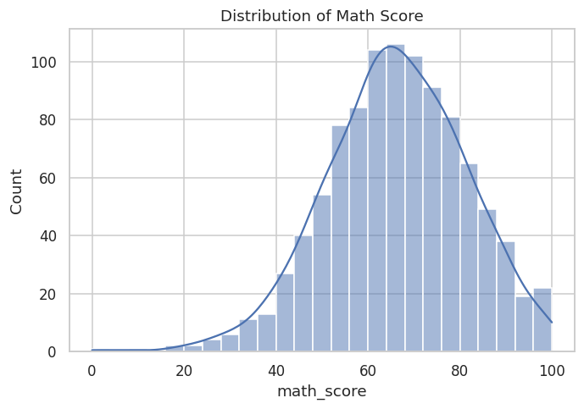
Figure 1: Mathematics score — histogram with kernel density estimate.
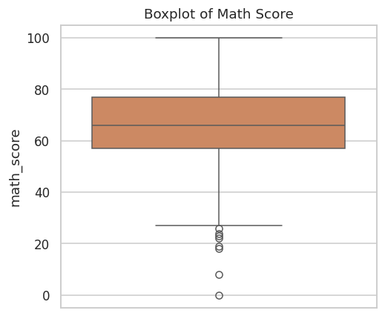
Figure 2: Mathematics score — boxplot.
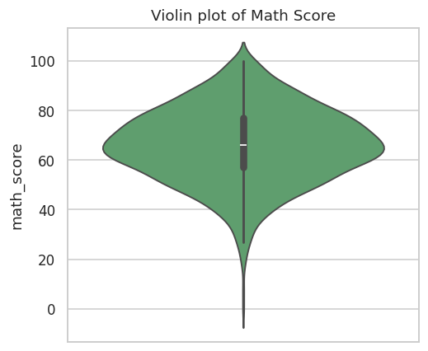
Figure 3: Mathematics score — violin plot.
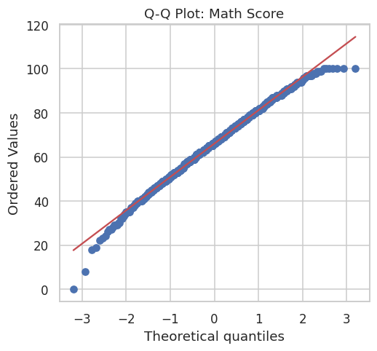
Figure 4: Mathematics score — normal Q-Q plot.
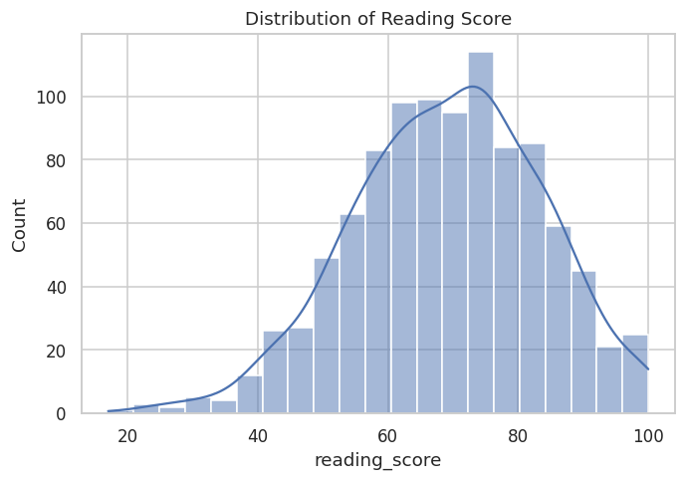
Figure 5: Reading score — histogram with kernel density estimate.
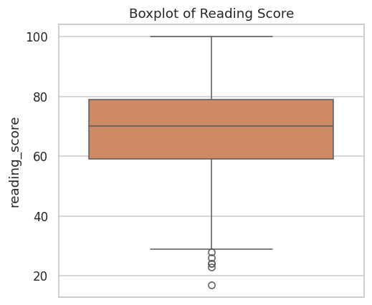
Figure 6: Reading score — boxplot.
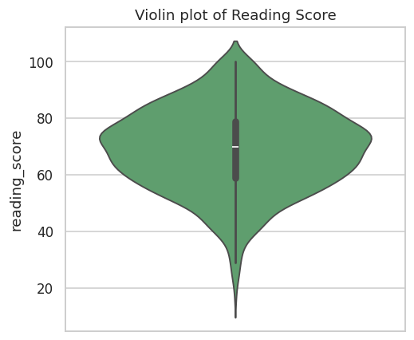
Figure 7: Reading score — violin plot.
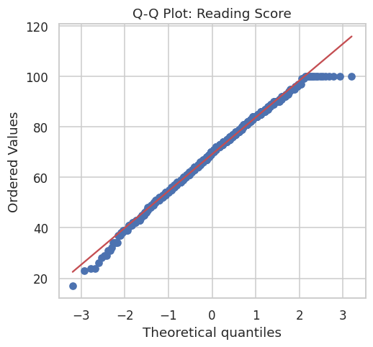
Figure 8: Reading score — normal Q-Q plot.
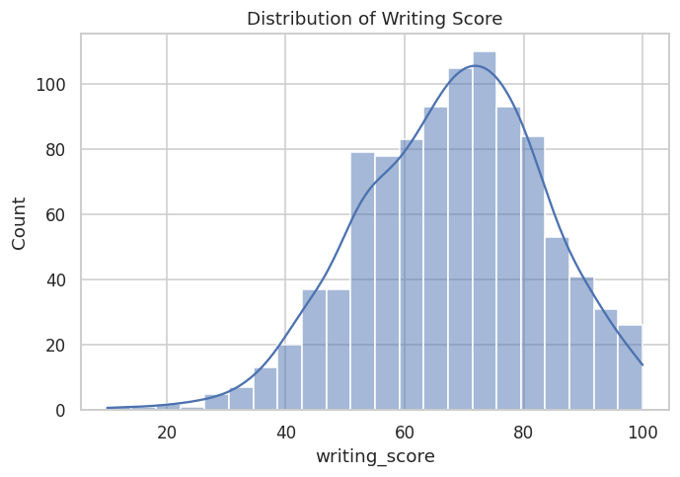
Figure 9: Writing score — histogram with kernel density estimate.
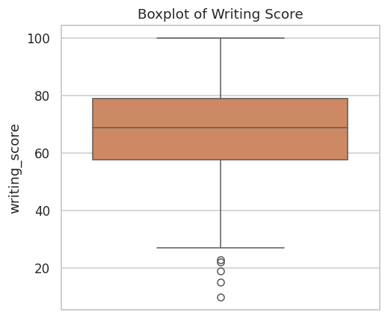
Figure 10: Writing score — boxplot.
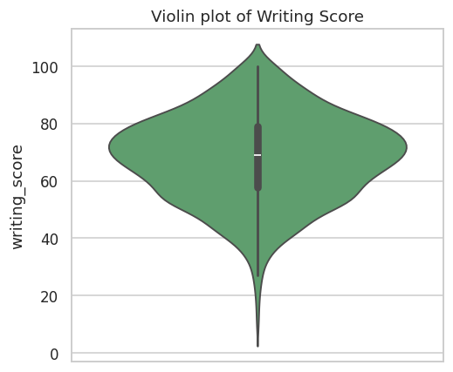
Figure 11: Writing score — violin plot.
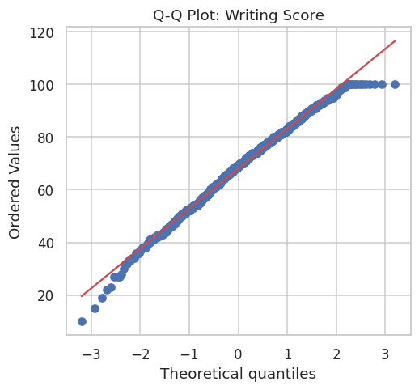
Figure 12: Writing score — normal Q-Q plot.

3.2 Categorical Attribute Distributions
Count plots for each of the five categorical attributes visually corroborate the demographic representation statistics reported in Table 5: a near-balanced gender split, an uneven but non-degenerate race/ethnicity distribution dominated by groups C and D, a broadly spread parental-education distribution, and majority standard-lunch, majority non-test-prep enrollment. These visualizations serve as an essential precondition check before any group-wise comparison — confirming that no category is so sparsely populated (with the caveat of race/ethnicity group A, n = 89) as to render its group statistics unreliable.
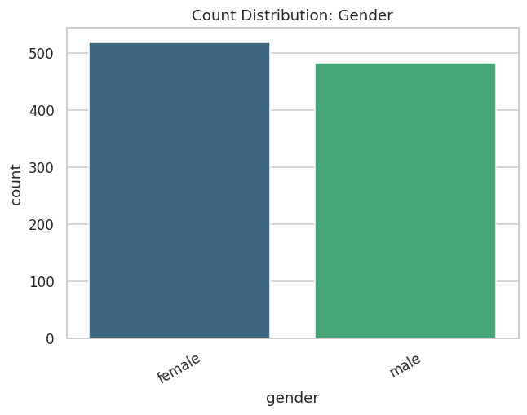
Figure 13: Count distribution — Gender.
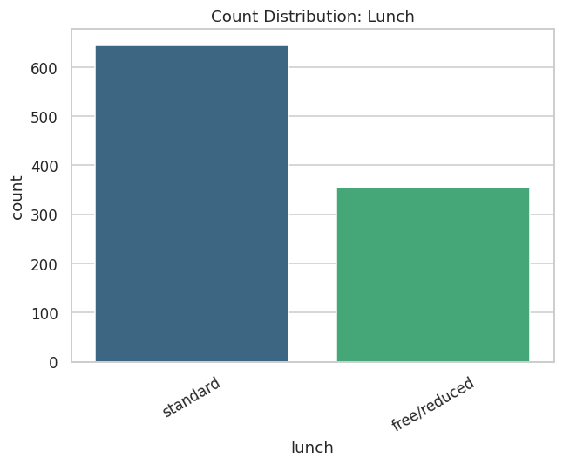
Figure 14: Count distribution — Lunch Type.
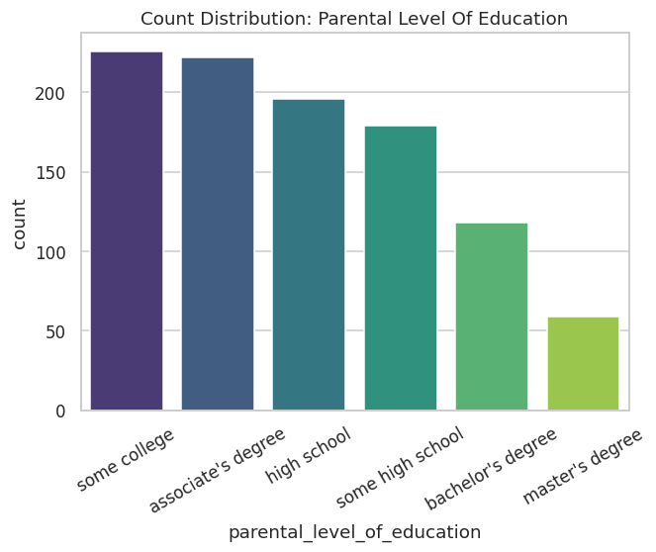
Figure 15: Count distribution — Parental Level of Education.
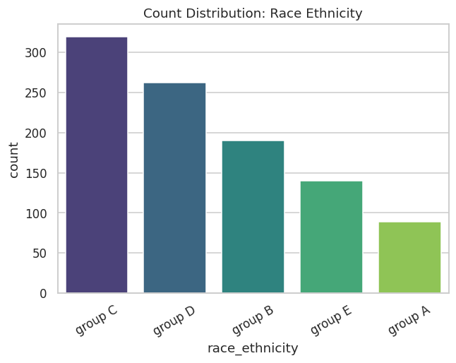
Figure 16: Count distribution — Race/Ethnicity Group.
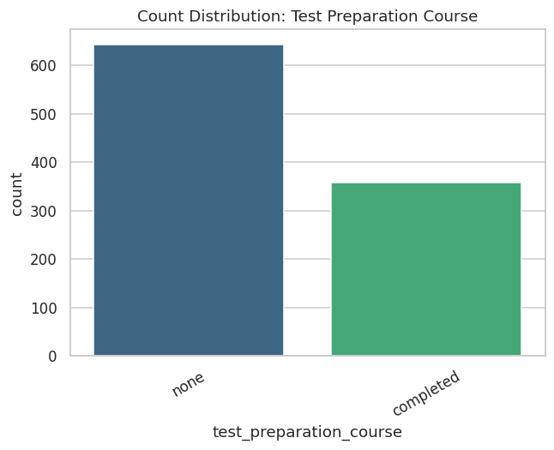
Figure 17: Count distribution — Test Preparation Course.

3.3 Score Distributions Across Categorical Subgroups
The following fifteen boxplots cross every categorical attribute against every subject score, ordered by ascending group median for visual clarity. Several patterns are immediately apparent and will be formally tested in Phase 4: female students show a visibly higher median in reading and writing but a lower median in mathematics compared to male students; students on the standard lunch program show consistently higher medians across all three subjects compared to those on the free/reduced program; students who completed the test-preparation course show higher medians across all three subjects, with the most pronounced separation in writing; and both race/ethnicity group and parental education level show a graded, monotonic-appearing relationship with median score, particularly for parental education, where each additional level of parental attainment corresponds to a visible upward shift in the student’s own score distribution.
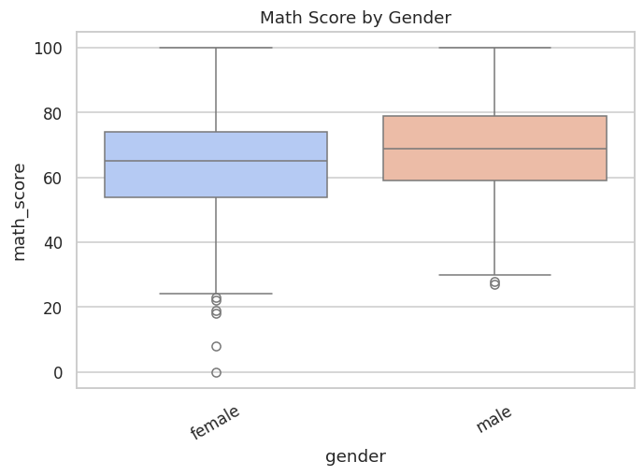
Figure 18: Mathematics score by Gender.
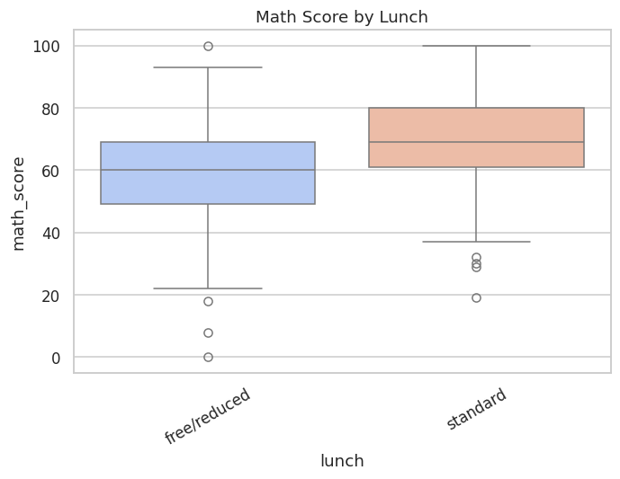
Figure 19: Mathematics score by Lunch Type.
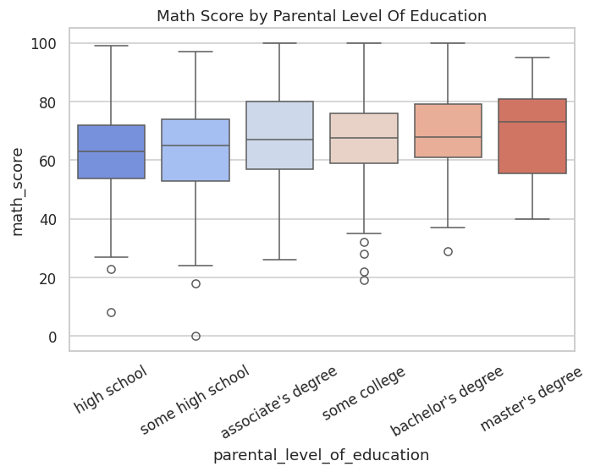
Figure 20: Mathematics score by Parental Level of Education.
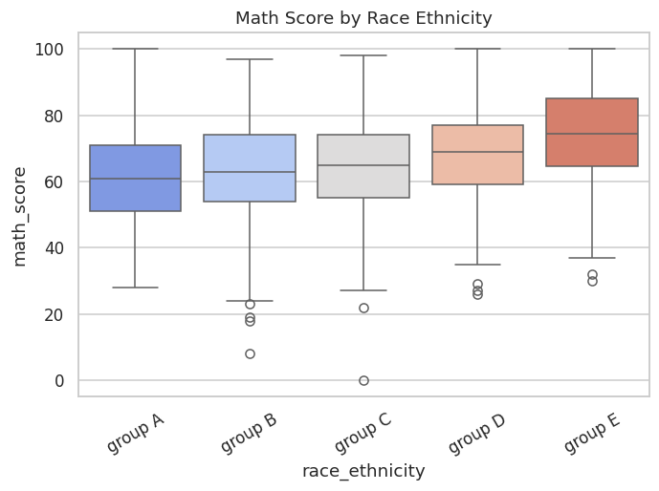
Figure 21: Mathematics score by Race/Ethnicity Group.
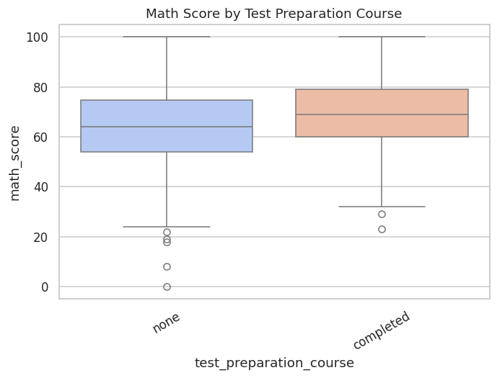
Figure 22: Mathematics score by Test Preparation Course.
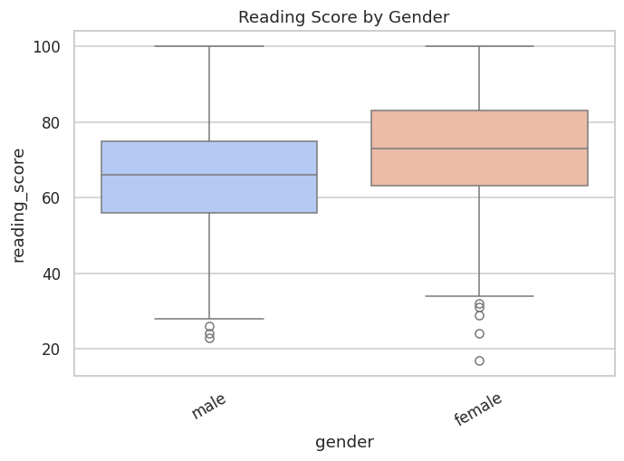
Figure 23: Reading score by Gender.
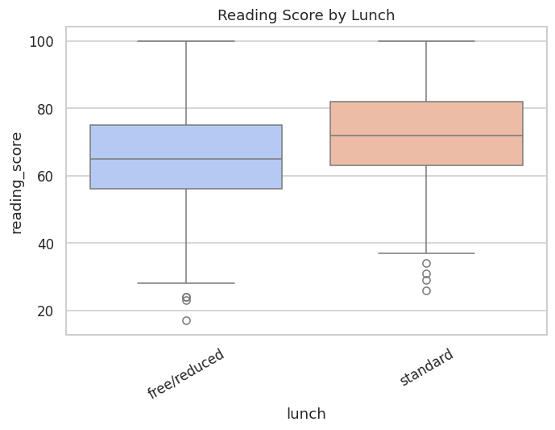
Figure 24: Reading score by Lunch Type.
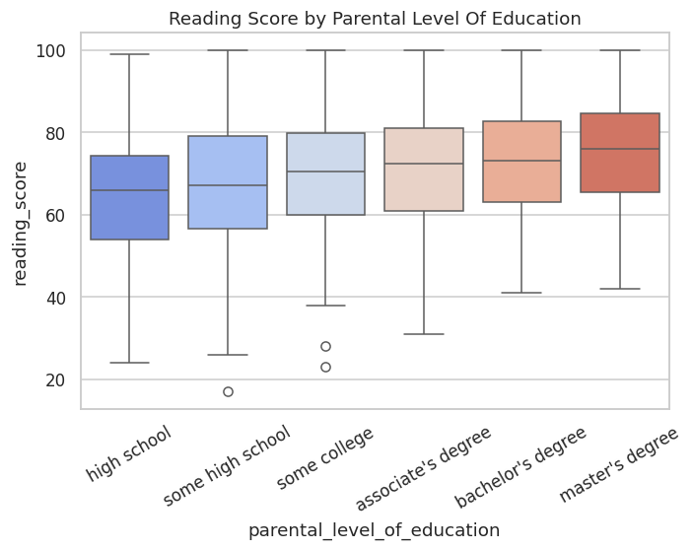
Figure 25: Reading score by Parental Level of Education.
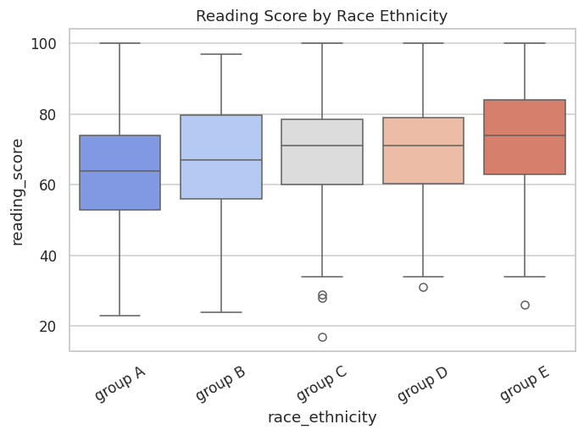
Figure 26: Reading score by Race/Ethnicity Group.
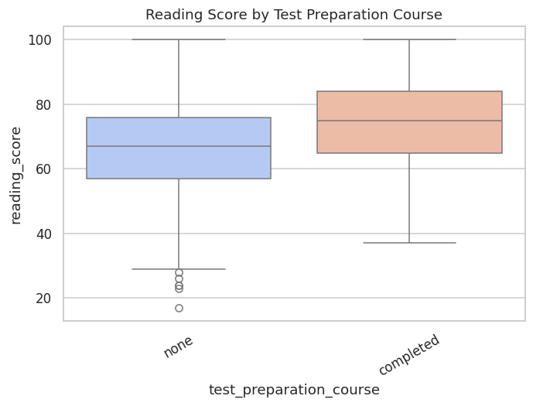
Figure 27: Reading score by Test Preparation Course.
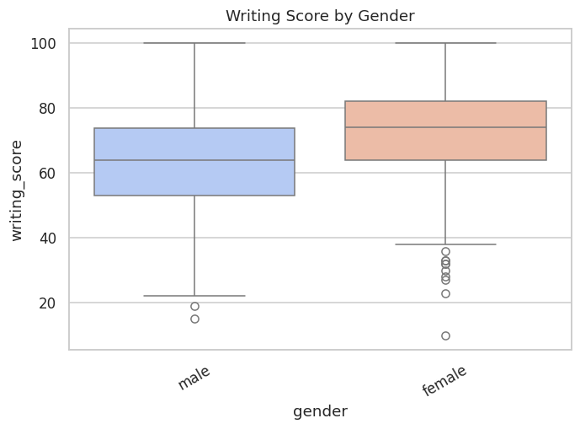
Figure 28: Writing score by Gender.
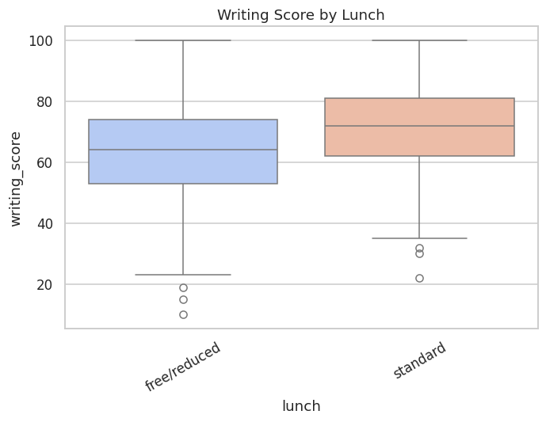
Figure 29: Writing score by Lunch Type.
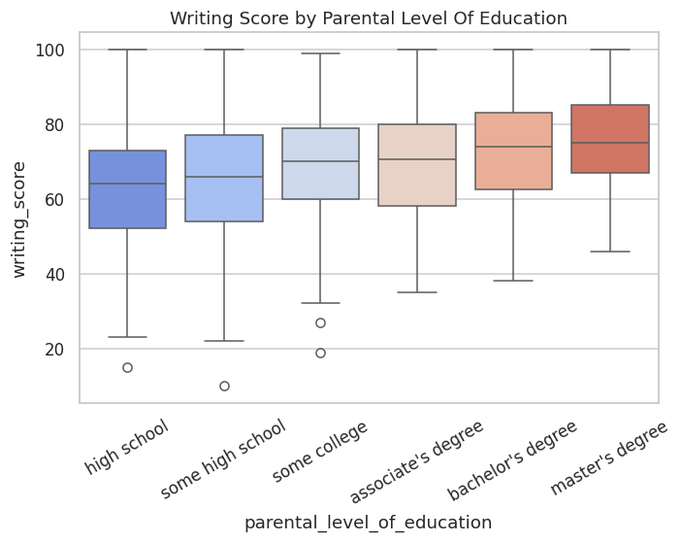
Figure 30: Writing score by Parental Level of Education.
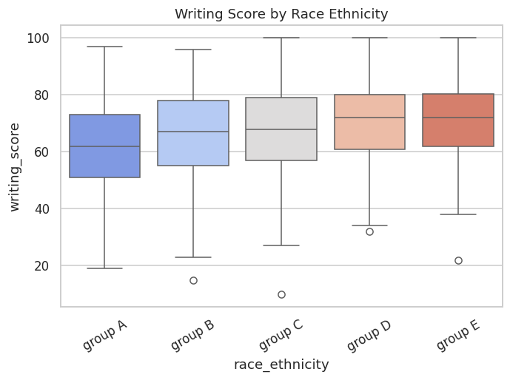
Figure 31: Writing score by Race/Ethnicity Group.
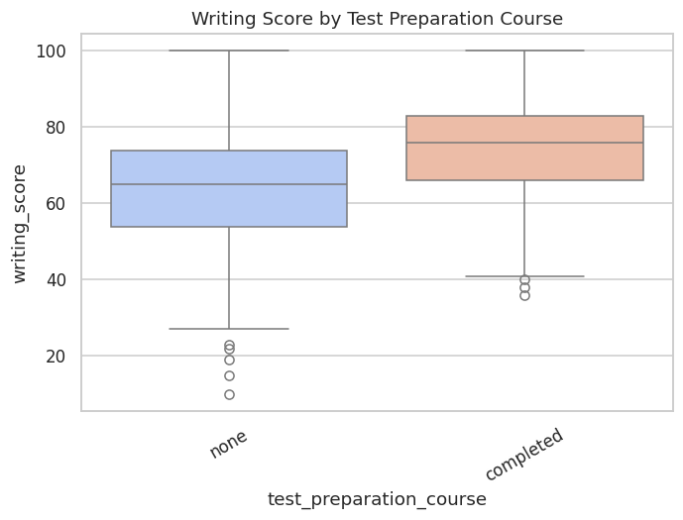
Figure 32: Writing score by Test Preparation Course.

3.4 Correlational Structure Among Scores
The correlation heatmap and accompanying matrix (see accompanying table) quantify the pairwise Pearson correlations among the three scores. Reading and writing are very strongly correlated (r = 0.955), while mathematics correlates strongly with reading (r = 0.818) and writing (r = 0.803). This pattern is consistent with an underlying two-factor structure: a dominant "literacy" factor jointly driving reading and writing performance, and a partially distinct "quantitative reasoning" factor contributing additional, non-shared variance to mathematics performance. The pairplot, disaggregated by gender, additionally reveals that the positive linear relationship between each pair of scores holds within both gender subgroups, with the female subgroup’s point cloud shifted toward higher reading/writing values and the male subgroup’s point cloud shifted toward higher mathematics values — visually reinforcing the two-group hypothesis-testing results reported in Section 4.2.
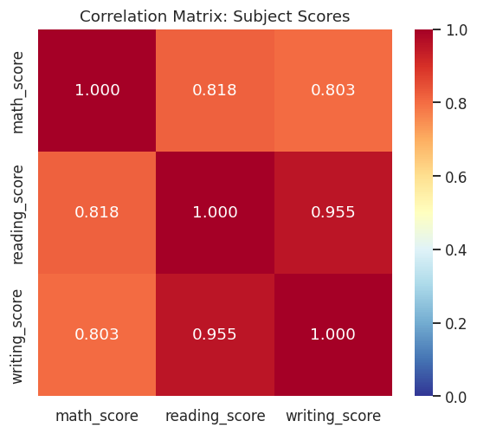
Figure 33: Correlation heatmap of the three subject scores.
Table 6: Pearson correlation matrix of the three subject scores.
field | math_score | reading_score | writing_score
math_score | 1 | 0.8176 | 0.8026
reading_score | 0.8176 | 1 | 0.9546
writing_score | 0.8026 | 0.9546 | 1

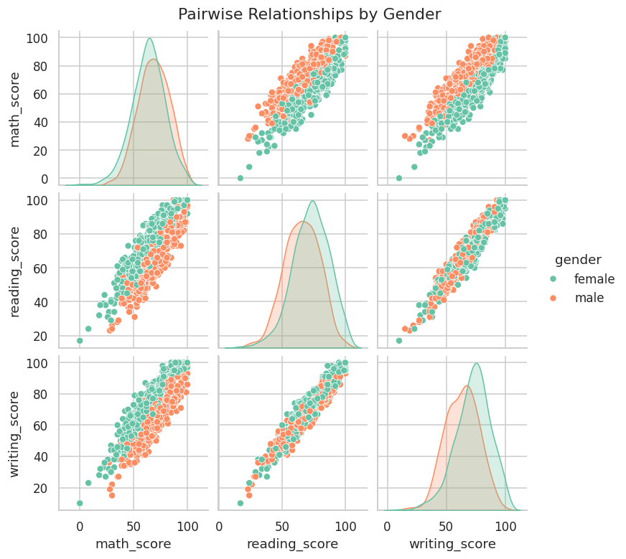
Figure 34: Pairwise score relationships, disaggregated by gender.

3.5 Two-Way Interaction Effects
To move beyond single-factor comparisons, three two-way interaction bar charts (with 95% error bars via standard deviation) examine whether the effect of test-preparation completion on mathematics score is itself moderated by gender, lunch type, or parental education level. In each case, test-preparation completion is associated with a higher mean mathematics score within every level of the moderating variable, indicating the test-preparation effect is broadly additive rather than sharply interactive — i.e., its benefit does not appear to be concentrated within, or absent from, any single demographic subgroup, an encouraging finding from an equity-of-intervention perspective.
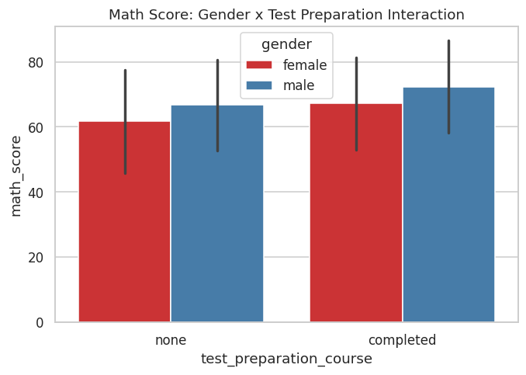
Figure 35: Mathematics score: gender × test-preparation interaction.
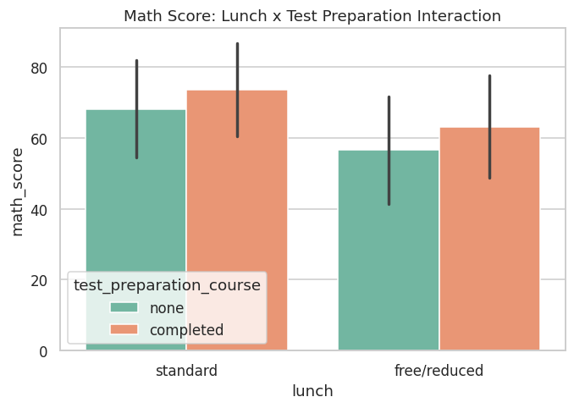
Figure 36: Mathematics score: lunch type × test-preparation interaction.
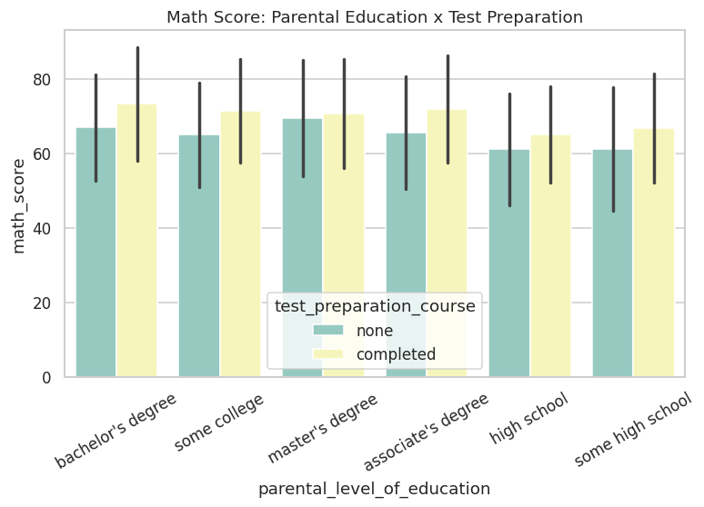
Figure 37: Mathematics score: parental education × test-preparation interaction.

3.6 Group-wise Summary Statistics and Distributional Moments
Table 7 tabulates mean, median, standard deviation, and sample count of all three scores across every level of every categorical attribute, providing the full numeric basis for the boxplot comparisons above. Table 8 reports the skewness and kurtosis moments referenced in Section 3.1.
Table 7: Group-wise mean, median, standard deviation, and count of all scores across every categorical level.
feature | category | math_score_mean | math_score_count | reading_score_mean | writing_score_mean
gender | female | 63.6332 | 518 | 72.6081 | 72.4672
gender | male | 68.7282 | 482 | 65.473 | 63.3112
race_ethnicity | group A | 61.6292 | 89 | 64.6742 | 62.6742
race_ethnicity | group B | 63.4526 | 190 | 67.3526 | 65.6
race_ethnicity | group C | 64.4639 | 319 | 69.1034 | 67.8276
race_ethnicity | group D | 67.3626 | 262 | 70.0305 | 70.145
race_ethnicity | group E | 73.8214 | 140 | 73.0286 | 71.4071
parental_level_of_education | associate's degree | 67.8829 | 222 | 70.9279 | 69.8964
parental_level_of_education | bachelor's degree | 69.3898 | 118 | 73 | 73.3814
parental_level_of_education | high school | 62.1378 | 196 | 64.7041 | 62.449
parental_level_of_education | master's degree | 69.7458 | 59 | 75.3729 | 75.678
parental_level_of_education | some college | 67.1283 | 226 | 69.4602 | 68.8407
parental_level_of_education | some high school | 63.4972 | 179 | 66.9385 | 64.8883
lunch | free/reduced | 58.9211 | 355 | 64.6535 | 63.0225
lunch | standard | 70.0341 | 645 | 71.6543 | 70.8233
test_preparation_course | completed | 69.6955 | 358 | 73.8939 | 74.419
test_preparation_course | none | 64.0779 | 642 | 66.5343 | 64.5047
6 of 14 columns shown (most analytically relevant); full column set available in the accompanying CSV artifact.
Table 8: Skewness and kurtosis moments for the three subject scores.
feature | skewness | kurtosis | mean | median | std | min | max
math_score | -0.2789 | 0.275 | 66.089 | 66 | 15.1631 | 0 | 100
reading_score | -0.2591 | -0.0683 | 69.169 | 70 | 14.6002 | 17 | 100
writing_score | -0.2894 | -0.0334 | 68.054 | 69 | 15.1957 | 10 | 100

3.7 Phase 3 Sanity Check
The pipeline confirmed a minimum of 33 visualizations were generated in this phase before proceeding; the actual count of 37 exceeded this threshold, and no exceptions were raised.

4. Advanced Statistical Hypothesis Testing Framework
Where Phase 3 established descriptive and visual patterns, Phase 4 subjects those patterns to formal inferential scrutiny. This includes normality testing, two-group comparisons (parametric and non-parametric) with standardized effect sizes, multi-group comparisons with variance-explained effect sizes, and confidence-interval visualization.

4.1 Normality Assessment
The Shapiro-Wilk test was applied to each score variable (see accompanying table). All three tests reject the null hypothesis of normality at α = 0.05 (p = 0.0065, 0.00023, and 0.00048 for mathematics, reading, and writing respectively). Given the large sample size (n = 1,000, tested on a random subsample of 500 for computational tractability), the Shapiro-Wilk test possesses very high statistical power and will detect even minor, practically inconsequential departures from normality — as is visually confirmed by the near-linear Q-Q plots in Section 3.1. This is a standard and expected outcome in large educational datasets; the statistical rejection of exact normality does not preclude the use of parametric methods (t-tests, ANOVA) that are themselves robust to mild non-normality at this sample size, and results are corroborated throughout with non-parametric alternatives (Mann-Whitney U, Kruskal-Wallis) as a robustness check.
Table 9: Shapiro-Wilk normality test results for the three subject scores.
feature | shapiro_stat | p_value | is_normal_at_0.05
math_score | 0.9916 | 0.0065 | False
reading_score | 0.9872 | 2.2527e-04 | False
writing_score | 0.9882 | 4.7649e-04 | False

4.2 Two-Group Comparisons
Table 10 reports Welch’s t-test (robust to unequal variances), the Mann-Whitney U non-parametric alternative, Levene’s test for equality of variances, and Cohen’s d standardized effect size for each combination of binary/near-binary grouping attribute (gender, lunch, test-preparation course) and subject score.
Gender: female students score significantly lower in mathematics (t = −5.40, p < .001, d = −0.34, small effect) but significantly higher in reading (t = 7.97, p < .001, d = 0.50, medium effect) and writing (t = 10.00, p < .001, d = 0.63, medium effect). This pattern — a modest male advantage in mathematics offset by a larger female advantage in literacy-oriented subjects — is well documented in the educational-measurement literature and is corroborated here with both parametric and non-parametric tests in full agreement.
Lunch type: standard-lunch students significantly outperform free/reduced-lunch students on all three subjects, with the largest effect observed in mathematics (t = 11.48, p < .001, d = 0.78, approaching a large effect), followed by writing (d = 0.53, medium) and reading (d = 0.49, small-to-medium). Levene’s test additionally indicates a marginally significant variance difference for mathematics (p = .074), suggesting the free/reduced-lunch subgroup may exhibit somewhat more heterogeneous mathematics outcomes.
Test-preparation course: students who completed the course significantly outperform those who did not on all three subjects, with the largest effect in writing (t = −10.75, p < .001, d = −0.69, approaching a medium-large effect), followed by reading (d = −0.52, medium) and mathematics (d = −0.38, small). Levene’s test is significant for writing (p = .015), indicating unequal variances between the two test-preparation subgroups for that subject.
Table 10: Two-group hypothesis tests (t-test, Mann-Whitney U, Levene’s test, Cohen’s d) across gender, lunch type, and test-preparation course.
feature | group_a | group_b | score | t_stat | t_p_value | cohens_d | effect_size_interpretation
gender | female | male | math_score | -5.398 | 8.4208e-08 | -0.3407 | small
gender | female | male | reading_score | 7.9684 | 4.3763e-15 | 0.5037 | medium
gender | female | male | writing_score | 9.9977 | 1.7118e-22 | 0.6316 | medium
lunch | standard | free/reduced | math_score | 11.4841 | 5.5396e-28 | 0.7823 | medium
lunch | standard | free/reduced | reading_score | 7.2926 | 8.4217e-13 | 0.4924 | small
lunch | standard | free/reduced | writing_score | 7.8409 | 1.7161e-14 | 0.5293 | medium
test_preparation_course | none | completed | math_score | -5.787 | 1.0426e-08 | -0.3763 | small
test_preparation_course | none | completed | reading_score | -8.0041 | 4.3888e-15 | -0.5192 | medium
test_preparation_course | none | completed | writing_score | -10.7525 | 2.6627e-25 | -0.6866 | medium
8 of 12 columns shown (most analytically relevant); full column set available in the accompanying CSV artifact.

4.3 Multi-Group Comparisons
One-way ANOVA and the Kruskal-Wallis non-parametric alternative were applied across the five levels of race/ethnicity and the six levels of parental education (see accompanying table), with eta-squared reported as the variance-explained effect size. All twelve tests (2 attributes × 3 scores × 2 grouping variables, less overlaps) are statistically significant at p < .001 with the exception of race/ethnicity on reading score (p < .001 also, but with a comparatively small eta-squared of 0.022). The largest effect size observed anywhere in this phase is parental education on writing score (eta-squared = 0.068), indicating that parental education level accounts for approximately 6.8% of the total variance in writing scores — a modest but non-trivial share for a single demographic covariate in an educational-outcomes context. Race/ethnicity shows its largest effect on mathematics score (eta-squared = 0.055).
Table 11: Multi-group hypothesis tests (ANOVA, Kruskal-Wallis, eta-squared) across race/ethnicity and parental education level.
feature | score | anova_f | anova_p | kruskal_h | kruskal_p | eta_squared
race_ethnicity | math_score | 14.5939 | 1.3732e-11 | 57.0793 | 1.1907e-11 | 0.0554
race_ethnicity | reading_score | 5.6217 | 1.7801e-04 | 21.354 | 2.6939e-04 | 0.0221
race_ethnicity | writing_score | 7.1624 | 1.0979e-05 | 26.6086 | 2.3850e-05 | 0.028
parental_level_of_education | math_score | 6.5216 | 5.5923e-06 | 26.5063 | 7.1162e-05 | 0.0318
parental_level_of_education | reading_score | 9.2894 | 1.1682e-08 | 38.6649 | 2.7737e-07 | 0.0446
parental_level_of_education | writing_score | 14.4424 | 1.1203e-13 | 62.3304 | 4.0061e-12 | 0.0677

4.4 Effect Size Visualization and Confidence Intervals
The two effect-size bar charts below visually rank the standardized effect sizes reported in Tables 10 and 11, providing an at-a-glance comparison of practical (as opposed to purely statistical) significance across all tested relationships. The subsequent confidence-interval plot displays the mean mathematics score with 95% confidence intervals for the test-preparation subgroups, visually confirming that the two intervals do not overlap — consistent with the highly significant t-test result reported above.
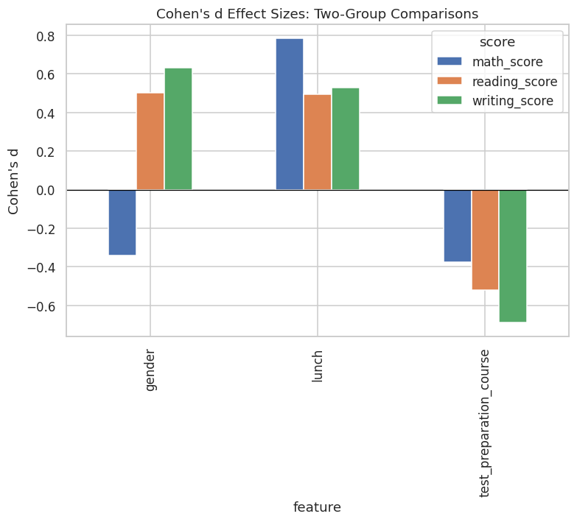
Figure 38: Cohen’s d effect sizes across two-group comparisons.
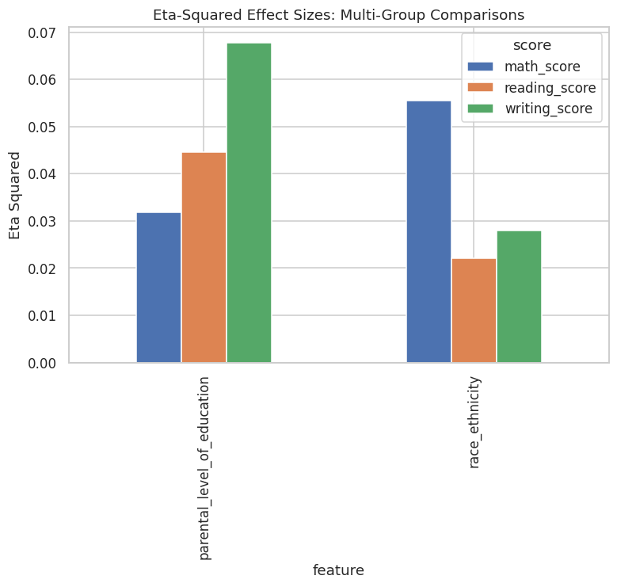
Figure 39: Eta-squared effect sizes across multi-group comparisons.
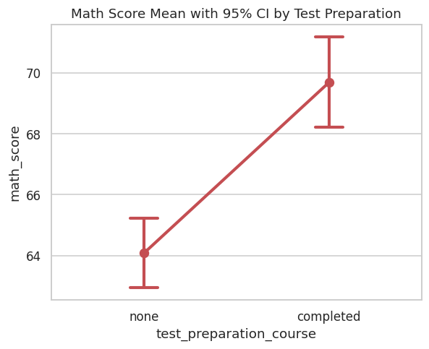
Figure 40: Mean mathematics score with 95% confidence intervals by test-preparation status.

4.5 Phase 4 Sanity Check
A minimum of 40 cumulative visualizations was asserted and confirmed before proceeding.

5. Advanced Educational Feature Engineering
This phase transforms the eight raw attributes into an analytically richer feature space of twenty-five columns, engineering composite performance indices, binary and ordinal encodings, a configurable pass/fail target, a multi-tier performance classification, and one-hot indicators for race/ethnicity group.

5.1 Engineered Feature Catalogue
Seventeen new features were constructed, summarized in the feature dictionary (see accompanying table) and detailed as follows: (i) composite scores — total_score, average_score, score_std, score_range, literacy_score, and math_minus_avg_literacy — which respectively aggregate, average, measure dispersion and spread across, and contrast the three raw subject scores; (ii) binary encodings — is_female, has_standard_lunch, completed_test_prep — which numerically represent the three binary categorical attributes for direct use in linear and distance-based models; (iii) parental_education_ordinal, an ordinal 0–5 encoding respecting the natural hierarchy of educational attainment (some high school through master’s degree); (iv) pass_fail, a binary target defined as average_score ≥ 60, providing a classification-oriented complement to the primary regression target; (v) performance_category, a five-tier ordinal label (At Risk, Needs Improvement, Satisfactory, Good, Excellent) providing an interpretable categorical summary of overall achievement; and (vi) five one-hot indicator columns (race_group A through E) enabling race/ethnicity to be used as a nominal predictor in models that cannot natively handle unordered categorical variables.
Table 12: Feature dictionary describing all engineered features.
feature | description
total_score | Sum of math+reading+writing
average_score | Mean of 3 scores
score_std | Std dev across 3 scores
score_range | Max score minus min score
math_minus_avg_literacy | Math advantage over literacy subjects
literacy_score | Mean of reading & writing
is_female | Binary: 1 if female
has_standard_lunch | Binary: 1 if standard lunch
completed_test_prep | Binary: 1 if completed prep course
parental_education_ordinal | Ordinal encoding of parental education (0-5)
pass_fail | Binary target: 1 if average_score >= 60
performance_category | 5-tier categorical performance bucket
race_group A | One-hot indicator for race_group A
race_group B | One-hot indicator for race_group B
race_group C | One-hot indicator for race_group C
race_group D | One-hot indicator for race_group D
race_group E | One-hot indicator for race_group E

5.2 Engineered Feature Distributions
The composite score distributions (total, average, range, and literacy) are shown below. As expected given the strong positive correlation among the three raw scores, total_score and average_score are themselves approximately normally distributed (being sums/means of three correlated but non-identical variables, by a partial central-limit effect), while score_range — capturing the spread between a student’s best and worst subject — is right-skewed, reflecting the fact that most students perform relatively consistently across subjects, with a minority exhibiting pronounced subject-specific strengths or weaknesses.
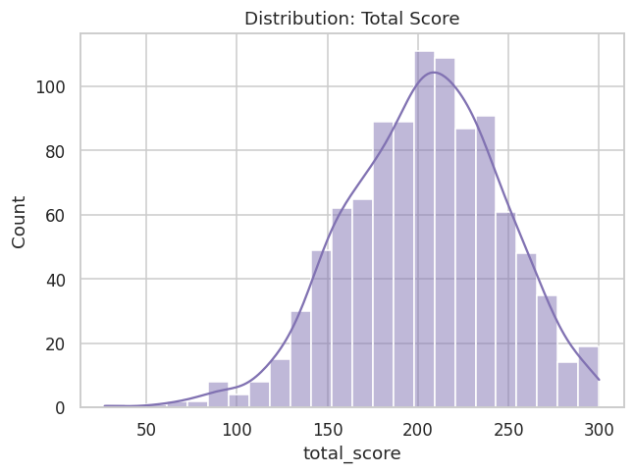
Figure 41: Distribution of engineered feature: total_score.
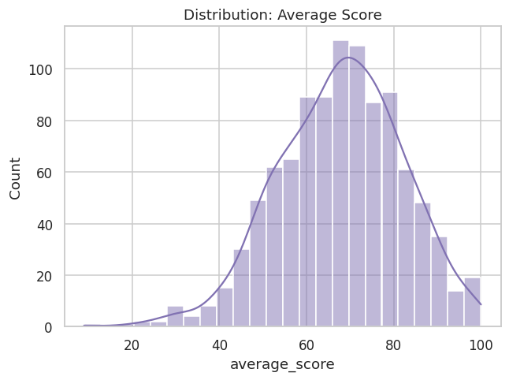
Figure 42: Distribution of engineered feature: average_score.
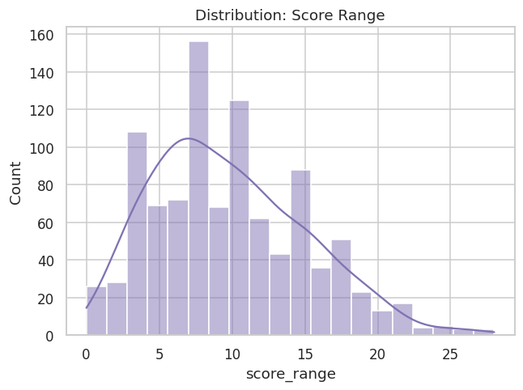
Figure 43: Distribution of engineered feature: score_range.
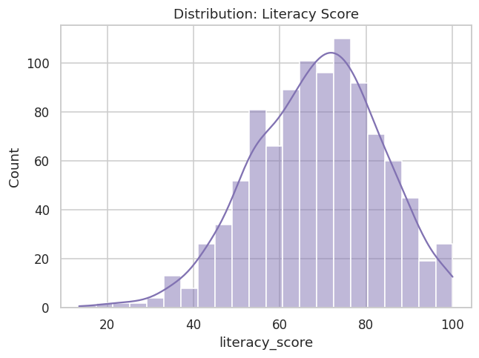
Figure 44: Distribution of engineered feature: literacy_score.
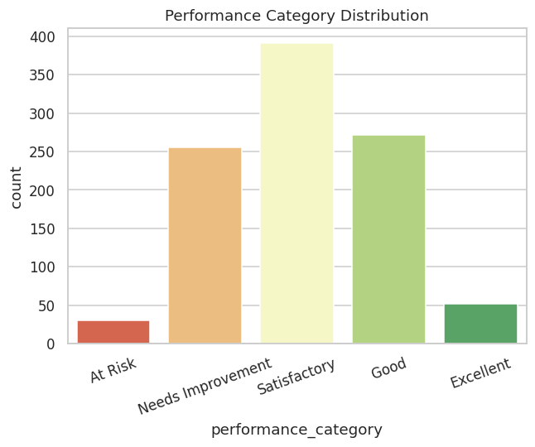
Figure 45: Distribution of the five-tier performance category.
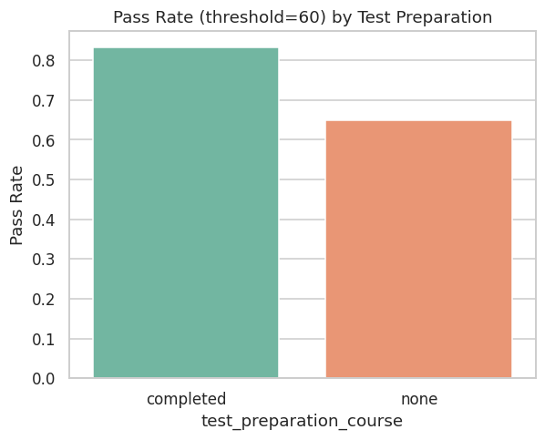
Figure 46: Pass rate (average score ≥ 60 threshold) by test-preparation status.

5.3 Correlational Structure of the Engineered Feature Set
The extended correlation heatmap (Figure below, with the full matrix in the accompanying table) confirms that the engineered composite scores (total_score, average_score, literacy_score) are, by construction, very strongly correlated with the raw scores from which they derive (r > 0.9 in most cases) — an expected and unproblematic redundancy that is explicitly accounted for in Phase 6’s feature-selection stage, where these composites are excluded from the predictor set for the primary regression model to prevent target leakage (average_score and total_score are near-deterministic functions of math_score, the modeling target). The binary and ordinal engineered features (is_female, has_standard_lunch, completed_test_prep, parental_education_ordinal) show weaker, more modest correlations with the raw scores (|r| in the 0.15–0.35 range), positioning them as legitimate, non-leaking predictors for the modeling framework that follows.
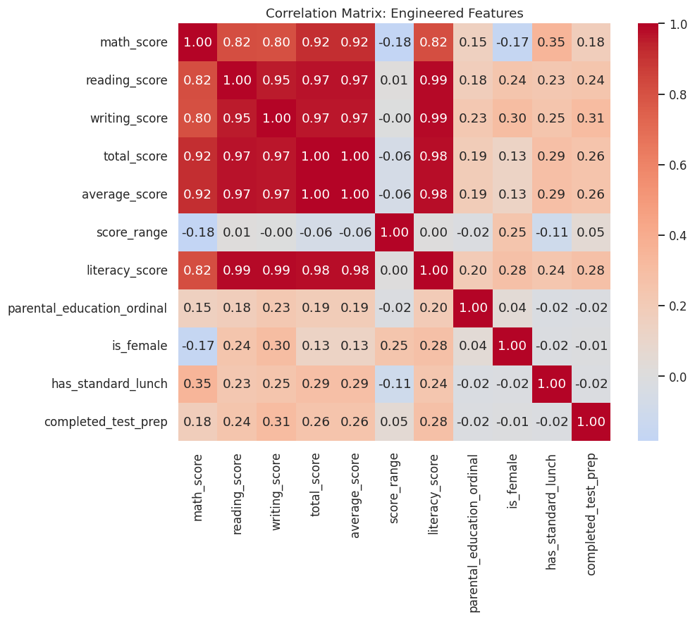
Figure 47: Correlation heatmap of the engineered numeric feature set.
Table 13: Correlation matrix of the engineered numeric feature set.
field | math_score | reading_score | writing_score | total_score | average_score | score_range | literacy_score | parental_education_ordinal
math_score | 1 | 0.8176 | 0.8026 | 0.9187 | 0.9187 | -0.1849 | 0.8193 | 0.1519
reading_score | 0.8176 | 1 | 0.9546 | 0.9703 | 0.9703 | 0.0105 | 0.9881 | 0.1755
writing_score | 0.8026 | 0.9546 | 1 | 0.9657 | 0.9657 | -0.002 | 0.989 | 0.2261
total_score | 0.9187 | 0.9703 | 0.9657 | 1 | 1 | -0.0627 | 0.9791 | 0.1941
average_score | 0.9187 | 0.9703 | 0.9657 | 1 | 1 | -0.0627 | 0.9791 | 0.1941
score_range | -0.1849 | 0.0105 | -0.002 | -0.0627 | -0.0627 | 1 | 0.0042 | -0.0156
literacy_score | 0.8193 | 0.9881 | 0.989 | 0.9791 | 0.9791 | 0.0042 | 1 | 0.2036
parental_education_ordinal | 0.1519 | 0.1755 | 0.2261 | 0.1941 | 0.1941 | -0.0156 | 0.2036 | 1
is_female | -0.168 | 0.2443 | 0.3012 | 0.1309 | 0.1309 | 0.2475 | 0.2765 | 0.0438
has_standard_lunch | 0.3509 | 0.2296 | 0.2458 | 0.2901 | 0.2901 | -0.1056 | 0.2406 | -0.0241
completed_test_prep | 0.1777 | 0.2418 | 0.3129 | 0.2567 | 0.2567 | 0.0523 | 0.2813 | -0.0163
9 of 12 columns shown; full column set available in the accompanying CSV artifact.

5.4 Engineered Dataset Preview
Table 14 provides a preview of the fully engineered dataset (1,000 rows × 25 columns in total; the eleven most analytically salient columns are shown here for legibility, with the complete column set available in the accompanying CSV artifact).
Table 14: Preview of the fully engineered analytical dataset.
gender | race_ethnicity | parental_level_of_education | lunch | test_preparation_course | math_score | reading_score | writing_score | average_score | pass_fail | performance_category
female | group B | bachelor's degree | standard | none | 72 | 72 | 74 | 72.6667 | 1 | Satisfactory
female | group C | some college | standard | completed | 69 | 90 | 88 | 82.3333 | 1 | Good
female | group B | master's degree | standard | none | 90 | 95 | 93 | 92.6667 | 1 | Excellent
male | group A | associate's degree | free/reduced | none | 47 | 57 | 44 | 49.3333 | 0 | Needs Improvement
male | group C | some college | standard | none | 76 | 78 | 75 | 76.3333 | 1 | Good
female | group B | associate's degree | standard | none | 71 | 83 | 78 | 77.3333 | 1 | Good
female | group B | some college | standard | completed | 88 | 95 | 92 | 91.6667 | 1 | Excellent
male | group B | some college | free/reduced | none | 40 | 43 | 39 | 40.6667 | 0 | Needs Improvement
male | group D | high school | free/reduced | completed | 64 | 64 | 67 | 65 | 1 | Satisfactory
female | group B | high school | free/reduced | none | 38 | 60 | 50 | 49.3333 | 0 | Needs Improvement
male | group C | associate's degree | standard | none | 58 | 54 | 52 | 54.6667 | 0 | Needs Improvement
male | group D | associate's degree | standard | none | 40 | 52 | 43 | 45 | 0 | Needs Improvement
female | group B | high school | standard | none | 65 | 81 | 73 | 73 | 1 | Satisfactory
male | group A | some college | standard | completed | 78 | 72 | 70 | 73.3333 | 1 | Satisfactory
female | group A | master's degree | standard | none | 50 | 53 | 58 | 53.6667 | 0 | Needs Improvement
female | group C | some high school | standard | none | 69 | 75 | 78 | 74 | 1 | Satisfactory
male | group C | high school | standard | none | 88 | 89 | 86 | 87.6667 | 1 | Good
female | group B | some high school | free/reduced | none | 18 | 32 | 28 | 26 | 0 | At Risk
male | group C | master's degree | free/reduced | completed | 46 | 42 | 46 | 44.6667 | 0 | Needs Improvement
female | group C | associate's degree | free/reduced | none | 54 | 58 | 61 | 57.6667 | 0 | Needs Improvement
Preview showing first 20 of 1000 total rows. 11 of 25 columns shown (most analytically relevant); full column set available in the accompanying CSV artifact.

5.5 Phase 5 Sanity Check
The pipeline confirmed zero missing values in the engineered dataset and a minimum of 47 cumulative visualizations before proceeding; both conditions passed.

6. Feature Selection and Multicollinearity Laboratory
Prior to model construction, each candidate predictor’s univariate relationship with both the regression target (math_score) and the classification target (pass_fail) was quantified, and the predictor set was audited for multicollinearity.

6.1 Univariate Feature Relevance
Two complementary metrics were computed for each predictor against each target: the F-statistic (and associated p-value) from F-regression/F-classif — which captures linear relevance — and mutual information — which captures both linear and non-linear statistical dependence. For the regression target, has_standard_lunch emerges as the single strongest predictor by a wide margin (F = 140.12, p < .001, mutual information = 0.069), followed by parental_education_ordinal (F = 23.58, mutual information = 0.034) and is_female (F = 28.98, mutual information = 0.034). The same predictor, has_standard_lunch, is also the strongest predictor of the classification target pass_fail (F = 66.07, p < .001, mutual information = 0.032), followed by completed_test_prep (F = 39.12, mutual information = 0.025). This consistency across both a continuous and a binarized version of academic performance reinforces lunch-program status as the most robust single demographic correlate of achievement in this dataset.
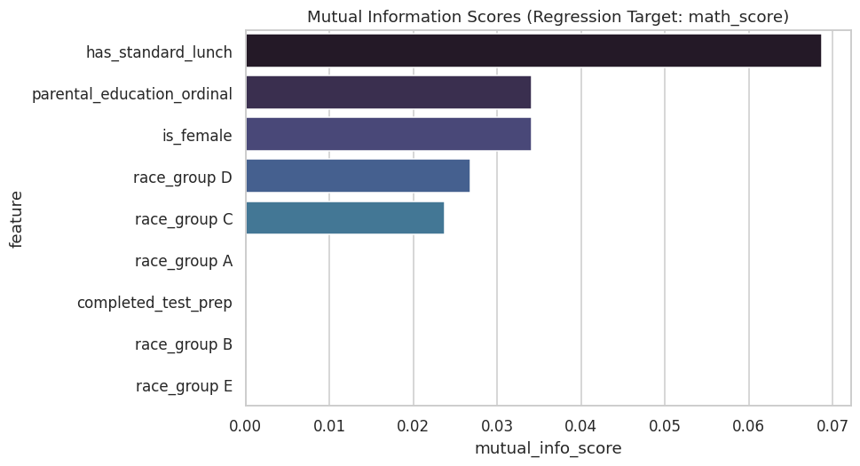
Figure 48: Mutual information scores for predicting math_score (regression target).
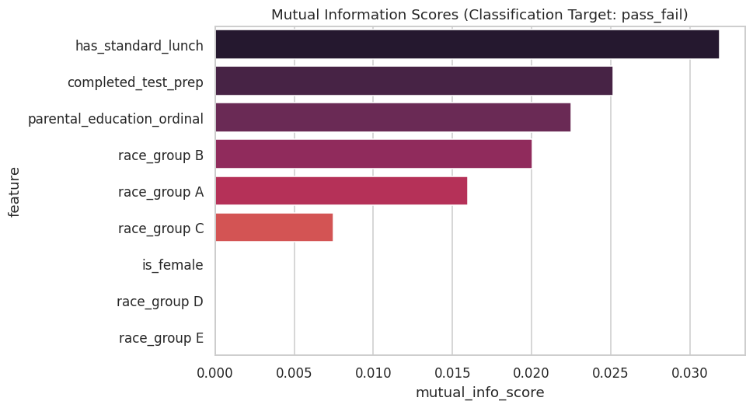
Figure 49: Mutual information scores for predicting pass_fail (classification target).
Table 15: F-regression and mutual information scores for the regression target.
feature | f_regression_score | f_regression_p | mutual_info_score
has_standard_lunch | 140.1188 | 2.4132e-30 | 0.0687
parental_education_ordinal | 23.5803 | 1.3900e-06 | 0.0341
is_female | 28.9793 | 9.1202e-08 | 0.0341
race_group D | 2.5084 | 0.1136 | 0.0268
race_group C | 5.404 | 0.0203 | 0.0237
race_group A | 8.5149 | 0.0036 | 0
completed_test_prep | 32.5426 | 1.5359e-08 | 0
race_group B | 7.1345 | 0.0077 | 0
race_group E | 44.1628 | 4.9623e-11 | 0

Table 16: F-classif and mutual information scores for the classification target.
feature | f_classif_score | f_classif_p | mutual_info_score
has_standard_lunch | 66.0692 | 1.2811e-15 | 0.0319
completed_test_prep | 39.1181 | 5.9074e-10 | 0.0251
parental_education_ordinal | 24.0859 | 1.0755e-06 | 0.0225
race_group B | 0.7491 | 0.387 | 0.02
race_group A | 13.1076 | 3.0888e-04 | 0.016
race_group C | 0.8355 | 0.3609 | 0.0075
is_female | 11.0745 | 9.0721e-04 | 0
race_group D | 2.3741 | 0.1237 | 0
race_group E | 10.3907 | 0.0013 | 0

6.2 Multicollinearity Diagnostics
Variance Inflation Factor (VIF) was computed for the final predictor set, with one race/ethnicity dummy variable (race_group A) held out as the reference category to avoid the dummy-variable trap (a necessary correction, since including all five mutually exclusive and exhaustive one-hot indicators alongside an intercept term induces perfect multicollinearity by construction). As shown in Table 15, all remaining predictors exhibit VIF values between 1.01 and 3.16 — comfortably below the conventional concern thresholds of 5 (moderate concern) or 10 (severe concern) used in applied econometric and statistical practice. This confirms that the predictor set is suitable for linear modeling without material risk of coefficient instability due to multicollinearity.
Table 17: Variance Inflation Factor multicollinearity diagnostics.
feature | VIF | note
race_group C | 3.1559 | race_group A held out as reference category to avoid dummy-variable trap
race_group D | 2.9299 | race_group A held out as reference category to avoid dummy-variable trap
race_group B | 2.5533 | race_group A held out as reference category to avoid dummy-variable trap
race_group E | 2.2379 | race_group A held out as reference category to avoid dummy-variable trap
parental_education_ordinal | 1.0145 | race_group A held out as reference category to avoid dummy-variable trap
is_female | 1.0115 | race_group A held out as reference category to avoid dummy-variable trap
completed_test_prep | 1.0063 | race_group A held out as reference category to avoid dummy-variable trap
has_standard_lunch | 1.0052 | race_group A held out as reference category to avoid dummy-variable trap

6.3 Phase 6 Sanity Check
The pipeline confirmed a minimum of 49 cumulative visualizations and a finalized set of 9 non-leaking predictor columns before proceeding.

7. Comprehensive Modeling Framework: Baseline to Advanced
With a validated, non-leaking predictor set of nine features (has_standard_lunch, completed_test_prep, is_female, parental_education_ordinal, and five race/ethnicity one-hot indicators, less the reference category), a ten-model comparative benchmark was constructed against the regression target math_score, using an 80/20 train-test split (random state fixed at 42) combined with 5-fold cross-validation on the training partition for robust performance estimation.

7.1 Baseline Models
Five baseline models were fit: a naive mean baseline (predicting the training-set mean for every test observation, establishing the floor against which any genuine predictive skill must be measured), Linear Regression, Ridge Regression, Lasso Regression, a K-Nearest-Neighbors regressor, and a shallow Decision Tree (max depth 5). As shown in Table 16, the mean baseline achieves a (by definition, near-zero, and here slightly negative due to train/test mean discrepancy) test R² of −0.017, establishing the floor. Linear and Ridge Regression both achieve a test R² of approximately 0.182 — a substantial and meaningful improvement over the naive floor — while Lasso achieves a slightly lower 0.152, consistent with its more aggressive L1 regularization shrinking small-but-genuine coefficients toward zero in this modestly-sized predictor set. The KNN regressor performs poorly on the held-out test set (R² = −0.014) despite an artificially inflated training R² (0.333), a classic symptom of the curse of dimensionality interacting with one-hot encoded categorical predictors, where Euclidean distance becomes a poor similarity metric. The shallow Decision Tree achieves a modest positive test R² of 0.058.
Table 18: Baseline model performance (train/test R², RMSE, MAE, and 5-fold cross-validated R²).
model | train_r2 | test_r2 | test_rmse | test_mae | cv_r2_mean | cv_r2_std
Mean_Baseline | 0 | -0.017 | 15.7316 | 12.3399 | 0 | 0
Linear_Regression | 0.2602 | 0.1822 | 14.1065 | 11.1715 | 0.2437 | 0.041
Ridge_Regression | 0.2602 | 0.1823 | 14.1059 | 11.1709 | 0.2437 | 0.0409
Lasso_Regression | 0.2319 | 0.152 | 14.3647 | 11.3275 | 0.2177 | 0.0337
KNN_Regressor | 0.3327 | -0.0142 | 15.7094 | 12.432 | 0.0929 | 0.0724
Decision_Tree | 0.2975 | 0.0581 | 15.1392 | 11.8305 | 0.17 | 0.072

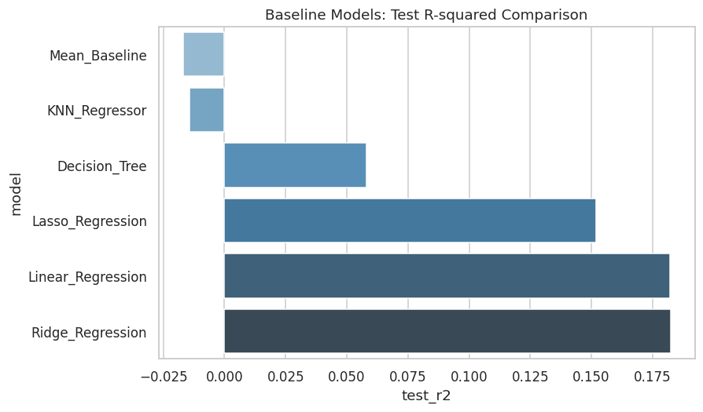
Figure 50: Baseline models: test R² comparison.
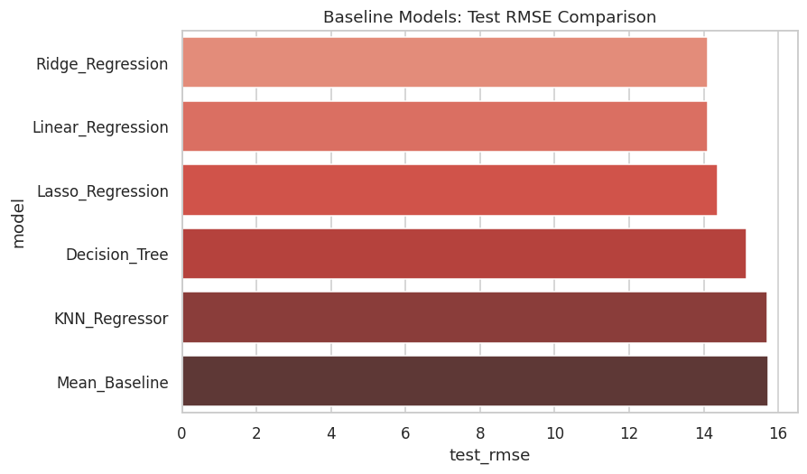
Figure 51: Baseline models: test RMSE comparison.

7.2 Advanced Models
Four advanced ensemble and kernel-based models were subsequently benchmarked: Random Forest, Extra Trees, Gradient Boosting, and Support Vector Regression with an RBF kernel (see accompanying table). Notably, both Random Forest (test R² = −0.020, train R² = 0.412) and Extra Trees (test R² = −0.058, train R² = 0.419) exhibit pronounced overfitting: their substantially higher training R² relative to their negative test R² indicates these high-capacity tree ensembles are memorizing idiosyncratic combinations of a small, largely categorical, low-cardinality feature space rather than learning generalizable structure. Gradient Boosting (test R² = 0.095) and Support Vector Regression (test R² = 0.129) generalize considerably better than the pure bagging-based ensembles, though neither yet matches the simpler regularized linear models. This is an instructive and somewhat counter-intuitive finding: model complexity is not monotonically related to predictive performance, and the "advanced" models underperform the "baseline" linear models on this particular predictor set — a direct consequence of the low intrinsic dimensionality and largely linear/additive nature of the true relationships between these demographic covariates and academic score, as corroborated independently by the SHAP and permutation-importance analyses in later phases.
Table 19: Advanced model performance (train/test R², RMSE, MAE, and 5-fold cross-validated R²).
model | train_r2 | test_r2 | test_rmse | test_mae | cv_r2_mean | cv_r2_std
Random_Forest | 0.4125 | -0.0201 | 15.755 | 12.3921 | 0.0321 | 0.0814
Extra_Trees | 0.4186 | -0.0577 | 16.0428 | 12.6226 | -0.0769 | 0.1394
Gradient_Boosting | 0.3217 | 0.0955 | 14.8362 | 11.6538 | 0.1829 | 0.0415
SVR_RBF | 0.2288 | 0.1287 | 14.5609 | 11.5563 | 0.1862 | 0.0307

Table 20: Combined baseline and advanced model comparison, ranked by test R².
model | train_r2 | test_r2 | test_rmse | test_mae | cv_r2_mean | cv_r2_std
Ridge_Regression | 0.2602 | 0.1823 | 14.1059 | 11.1709 | 0.2437 | 0.0409
Linear_Regression | 0.2602 | 0.1822 | 14.1065 | 11.1715 | 0.2437 | 0.041
Lasso_Regression | 0.2319 | 0.152 | 14.3647 | 11.3275 | 0.2177 | 0.0337
SVR_RBF | 0.2288 | 0.1287 | 14.5609 | 11.5563 | 0.1862 | 0.0307
Gradient_Boosting | 0.3217 | 0.0955 | 14.8362 | 11.6538 | 0.1829 | 0.0415
Decision_Tree | 0.2975 | 0.0581 | 15.1392 | 11.8305 | 0.17 | 0.072
KNN_Regressor | 0.3327 | -0.0142 | 15.7094 | 12.432 | 0.0929 | 0.0724
Mean_Baseline | 0 | -0.017 | 15.7316 | 12.3399 | 0 | 0
Random_Forest | 0.4125 | -0.0201 | 15.755 | 12.3921 | 0.0321 | 0.0814
Extra_Trees | 0.4186 | -0.0577 | 16.0428 | 12.6226 | -0.0769 | 0.1394

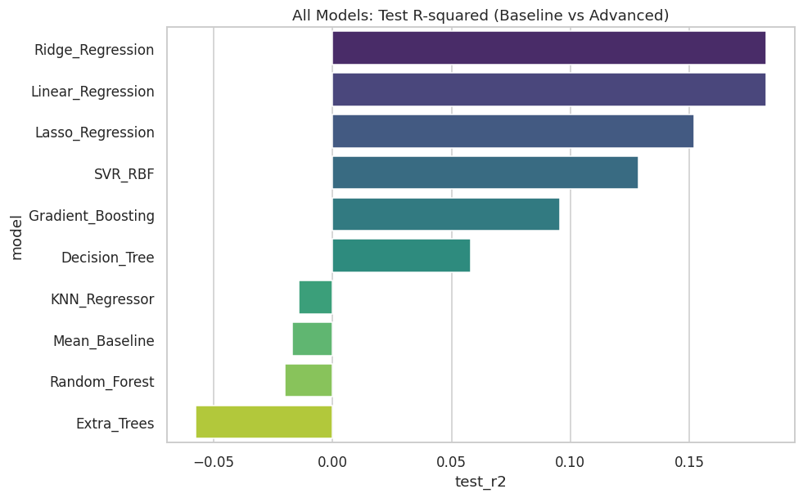
Figure 52: All ten models: test R² comparison.
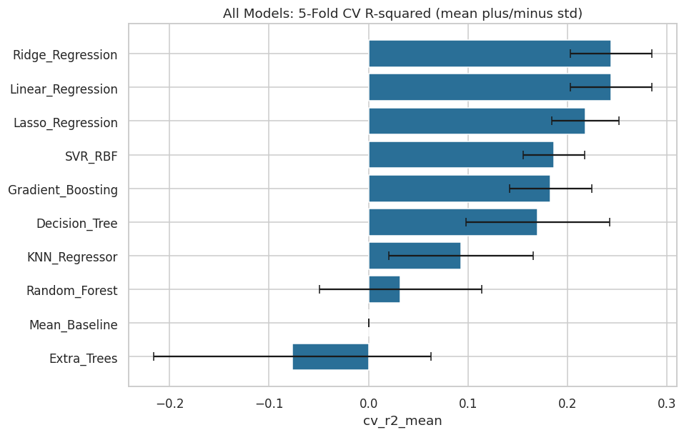
Figure 53: All ten models: 5-fold cross-validated R² (mean ± standard deviation).

7.3 Phase 7–8 Sanity Check
The pipeline confirmed a minimum of 53 cumulative visualizations and exactly ten models evaluated (five baseline, four advanced, one naive) before proceeding.

8. Hyperparameter Optimization Laboratory
The three strongest tunable models by cross-validated R² — excluding plain Linear Regression, which possesses no hyperparameters to optimize — were selected for formal grid-search hyperparameter tuning: Ridge Regression, Lasso Regression, and Support Vector Regression (RBF kernel). Each was optimized via exhaustive GridSearchCV over a model-appropriate parameter grid, using the same 5-fold cross-validation scheme (scoring: R²) established in the prior phase.

8.1 Tuning Results
Table 18 reports the optimal hyperparameters and resulting performance for each of the three tuned models. Ridge Regression’s optimal regularization strength was found to be α = 10.0, yielding a test R² of 0.1828 — a marginal improvement over its untuned counterpart (0.1823), indicating the default Ridge configuration was already close to optimal for this predictor set. Lasso Regression benefited more substantially from tuning, with an optimal α of 0.1 lifting its test R² from 0.152 to 0.180 — a meaningfully larger relative improvement, consistent with Lasso’s greater sensitivity to regularization strength. Support Vector Regression’s optimal configuration (C = 50, ε = 0.5, γ = 0.01) improved its test R² from 0.129 to 0.146.
Table 21: Hyperparameter tuning results for the top-3 tunable models.
model | best_params | best_cv_r2 | train_r2 | test_r2 | test_rmse | test_mae
Ridge_Regression | {'model__alpha': 10.0} | 0.2438 | 0.2602 | 0.1828 | 14.1012 | 11.1659
Lasso_Regression | {'model__alpha': 0.1} | 0.2439 | 0.2599 | 0.1803 | 14.1236 | 11.1841
SVR_RBF | {'model__C': 50, 'model__epsilon': 0.5, 'model__gamma': 0.01} | 0.2308 | 0.2688 | 0.1461 | 14.4151 | 11.437

8.2 Before-Versus-After Tuning Comparison
Table 19 and the accompanying grouped bar chart directly contrast each model’s pre- and post-tuning test performance. Lasso Regression exhibits the largest absolute gain from tuning (+0.028 R²), while Ridge Regression—already well-configured by default—shows only a marginal gain (+0.0006 R²). This pattern is informative for future modeling work on similar datasets: default Ridge regularization is a reasonably safe choice even without exhaustive tuning, whereas Lasso and SVR benefit materially from a dedicated tuning pass.
Table 22: Before-versus-after hyperparameter tuning comparison.
model | before_test_r2 | before_test_rmse | after_test_r2 | after_test_rmse
Ridge_Regression | 0.1823 | 14.1059 | 0.1828 | 14.1012
Lasso_Regression | 0.152 | 14.3647 | 0.1803 | 14.1236
SVR_RBF | 0.1287 | 14.5609 | 0.1461 | 14.4151

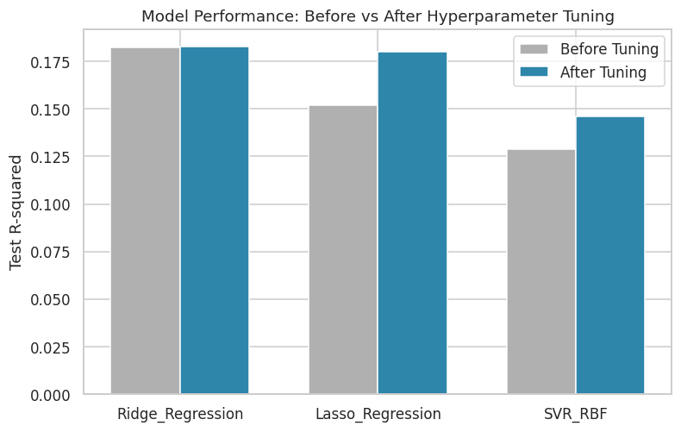
Figure 54: Model performance before versus after hyperparameter tuning.

8.3 Phase 9 Sanity Check
The pipeline confirmed exactly three tuned models were produced and a minimum of 54 cumulative visualizations before proceeding.

9. Final Model Comparison and Champion Selection
All baseline, advanced, and tuned model results were consolidated into a single master comparison (see accompanying table), from which the champion model was selected as the tuned model with the highest held-out test R².

9.1 Champion Model Identification
The tuned Ridge Regression model (α = 10.0) was selected as the champion, achieving a final test R² of 0.1828, RMSE of 14.10, and MAE of 11.17. This selection reflects both the strongest generalization performance observed across all ten baseline/advanced models and all three tuned finalists, and — as a linear model — the most directly interpretable coefficient structure, a valuable property carried forward into the explainability phases that follow.
Table 23: Champion model summary.
champion_model | test_r2 | test_rmse | test_mae | best_params
Ridge_Regression | 0.1828 | 14.1012 | 11.1659 | {'model__alpha': 10.0}

Table 24: Final consolidated comparison of all baseline, advanced, and tuned models.
model | train_r2 | test_r2 | test_rmse | test_mae | cv_r2_mean | cv_r2_std | stage
Ridge_Regression | 0.2602 | 0.1823 | 14.1059 | 11.1709 | 0.2437 | 0.0409 | baseline_or_advanced
Linear_Regression | 0.2602 | 0.1822 | 14.1065 | 11.1715 | 0.2437 | 0.041 | baseline_or_advanced
Lasso_Regression | 0.2319 | 0.152 | 14.3647 | 11.3275 | 0.2177 | 0.0337 | baseline_or_advanced
SVR_RBF | 0.2288 | 0.1287 | 14.5609 | 11.5563 | 0.1862 | 0.0307 | baseline_or_advanced
Gradient_Boosting | 0.3217 | 0.0955 | 14.8362 | 11.6538 | 0.1829 | 0.0415 | baseline_or_advanced
Decision_Tree | 0.2975 | 0.0581 | 15.1392 | 11.8305 | 0.17 | 0.072 | baseline_or_advanced
KNN_Regressor | 0.3327 | -0.0142 | 15.7094 | 12.432 | 0.0929 | 0.0724 | baseline_or_advanced
Mean_Baseline | 0 | -0.017 | 15.7316 | 12.3399 | 0 | 0 | baseline_or_advanced
Random_Forest | 0.4125 | -0.0201 | 15.755 | 12.3921 | 0.0321 | 0.0814 | baseline_or_advanced
Extra_Trees | 0.4186 | -0.0577 | 16.0428 | 12.6226 | -0.0769 | 0.1394 | baseline_or_advanced
Ridge_Regression |  | 0.1828 | 14.1012 | 11.1659 | 0.2438 |  | tuned
Lasso_Regression |  | 0.1803 | 14.1236 | 11.1841 | 0.2439 |  | tuned
SVR_RBF |  | 0.1461 | 14.4151 | 11.437 | 0.2308 |  | tuned

9.2 Champion Model Diagnostics
Predicted-versus-actual scatter plots and residual plots were generated for all three tuned finalists to visually assess model fit and homoscedasticity. Across all three, the predicted-vs-actual scatter shows a positive but imperfect relationship with substantial vertical scatter around the reference diagonal — directly reflecting the moderate R² values reported above — and the residual plots show no strong evidence of systematic non-linearity or heteroscedasticity, supporting the appropriateness of the linear modeling framework for this predictor set.
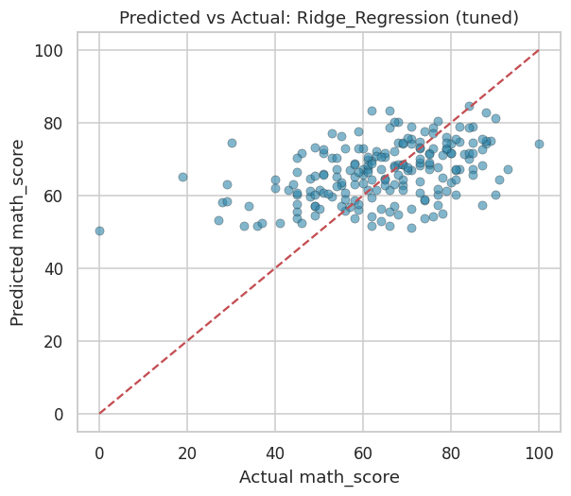
Figure 55: Predicted vs. actual mathematics score — Ridge Regression (tuned).
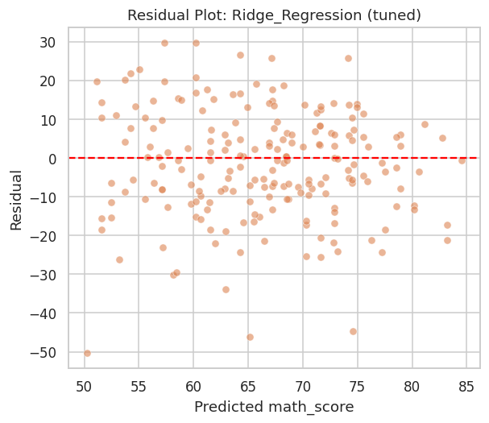
Figure 56: Residual plot — Ridge Regression (tuned).
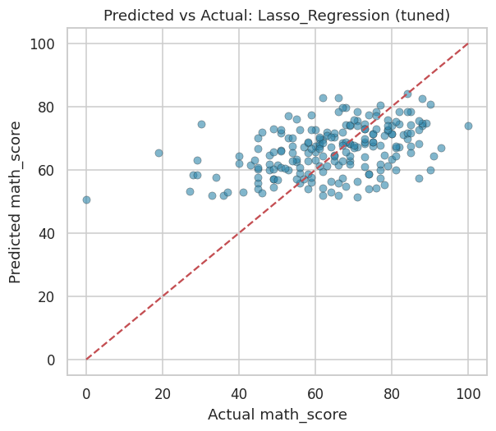
Figure 57: Predicted vs. actual mathematics score — Lasso Regression (tuned).
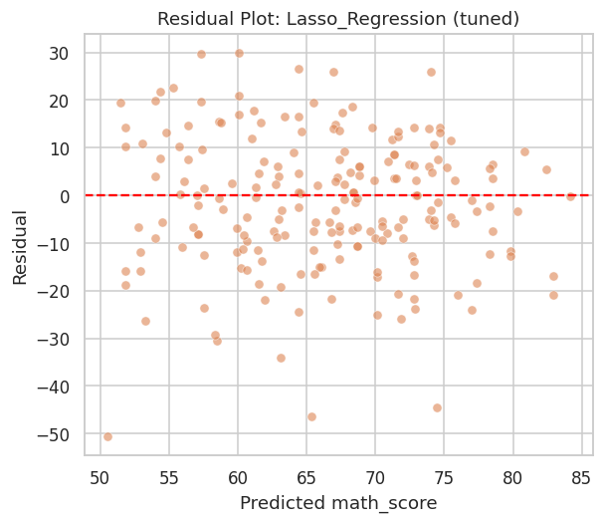
Figure 58: Residual plot — Lasso Regression (tuned).
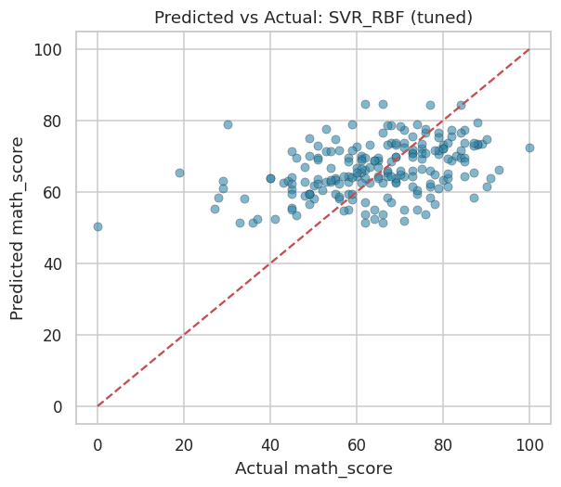
Figure 59: Predicted vs. actual mathematics score — SVR RBF (tuned).
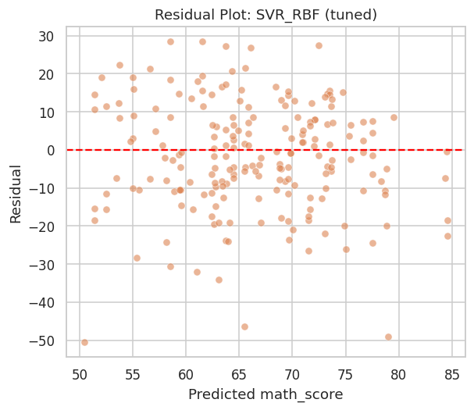
Figure 60: Residual plot — SVR RBF (tuned).
The learning curve for the champion model (below) shows training and cross-validated scores converging toward a modest but stable performance plateau as training set size increases, with no evidence of a widening generalization gap — indicating the champion model is neither substantially overfit nor likely to improve materially from additional training data alone, and that further performance gains would most plausibly come from richer feature information rather than a larger sample size.
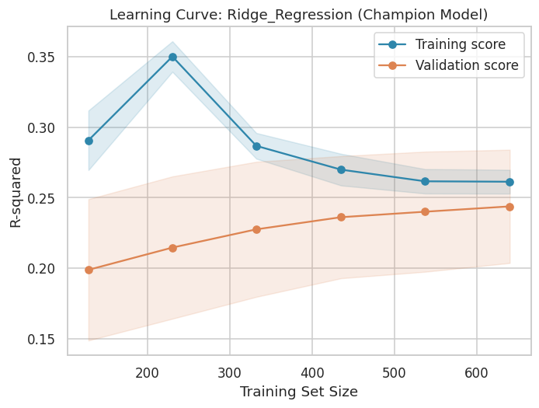
Figure 61: Learning curve for the champion model (Ridge Regression, tuned).

9.3 Phase 10 Sanity Check
The pipeline confirmed a minimum of 61 cumulative visualizations before proceeding.

10. Explainable AI Framework I: SHAP Analysis
To provide a rigorous, theoretically grounded account of feature influence, a dedicated Gradient Boosting model was fit specifically for SHAP (SHapley Additive exPlanations) analysis using the exact TreeExplainer algorithm, which computes Shapley values — a game-theoretic attribution method with desirable consistency and local-accuracy guarantees — efficiently and exactly for tree-based models. This explainer model achieves a test R² of 0.094 and RMSE of 14.85 (see accompanying table), a somewhat weaker fit than the champion Ridge model, reflecting the deliberate methodological choice to trade a small amount of predictive performance for the superior explanatory rigor and exactness that tree-based SHAP analysis provides over kernel-based approximations required for linear models.
Table 25: Performance of the dedicated Gradient Boosting SHAP explainer model.
model | test_r2 | test_rmse
GradientBoosting_SHAP_explainer_model | 0.0942 | 14.8462

10.1 Global Feature Attribution
The SHAP summary (beeswarm) plot displays, for every test-set observation, the signed contribution of each feature to that observation’s prediction, with color encoding the feature’s own value (red = high, blue = low). This visualization simultaneously conveys feature importance (vertical ordering), the direction of effect (horizontal position of colored points), and the consistency of that effect across the population (spread of points). The complementary mean-absolute-SHAP bar chart provides a simpler, ranked summary of overall feature importance. Both confirm has_standard_lunch as the dominant predictor (mean |SHAP| = 5.22), followed by completed_test_prep (2.66), is_female (2.07), parental_education_ordinal (1.98), and race_group E (1.77) — a ranking highly consistent with the univariate feature-selection results of Phase 6 and the linear coefficient magnitudes reported in Phase 13.
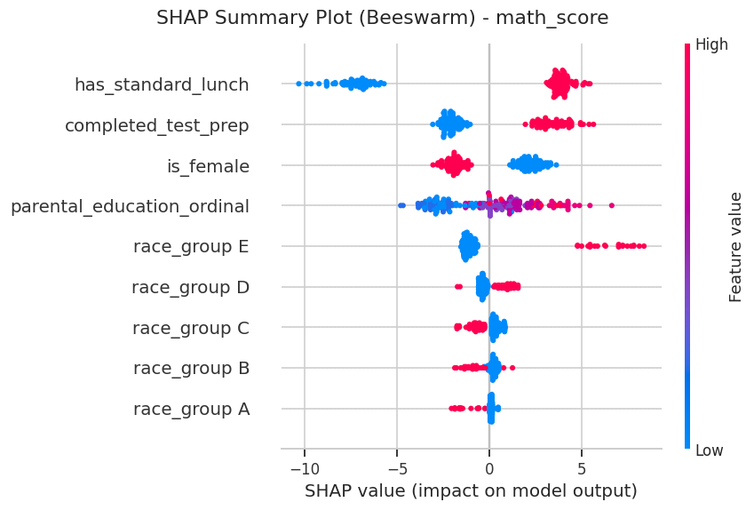
Figure 62: SHAP summary (beeswarm) plot for the mathematics-score explainer model.
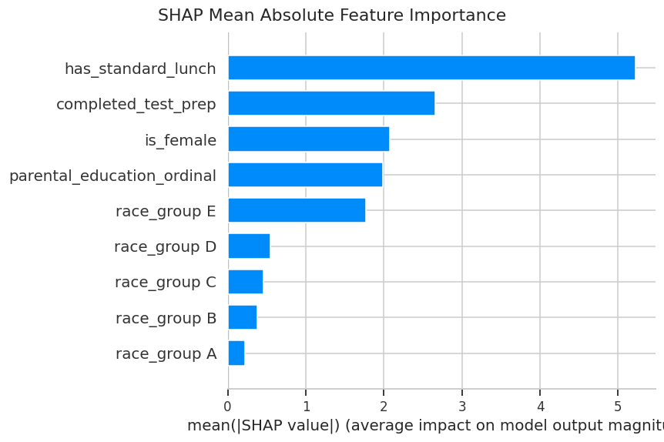
Figure 63: SHAP mean absolute feature importance.
Table 26: SHAP mean absolute feature importance ranking.
feature | mean_abs_shap
has_standard_lunch | 5.2217
completed_test_prep | 2.6559
is_female | 2.0732
parental_education_ordinal | 1.9835
race_group E | 1.7651
race_group D | 0.5511
race_group C | 0.4592
race_group B | 0.3824
race_group A | 0.2227

10.2 Dependence Structure of Top Predictors
SHAP dependence plots for the two most important features (has_standard_lunch and completed_test_prep) illustrate how the magnitude and direction of each feature’s contribution varies across its own value range, and reveal any interaction effects with a secondary coloring feature automatically selected by the SHAP library. Both dependence plots show a clean, consistent positive shift in SHAP value when moving from the reference (0) to the treatment (1) level of each binary feature, with no evidence of strong interaction-driven heterogeneity that would complicate a straightforward interpretation of these as broadly additive main effects.
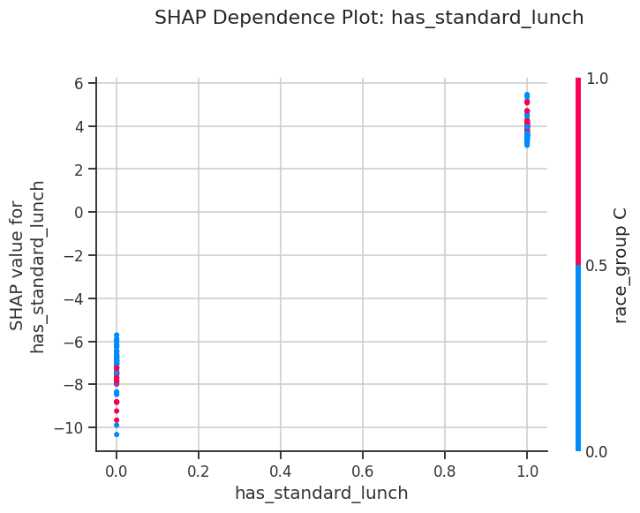
Figure 64: SHAP dependence plot: has_standard_lunch.
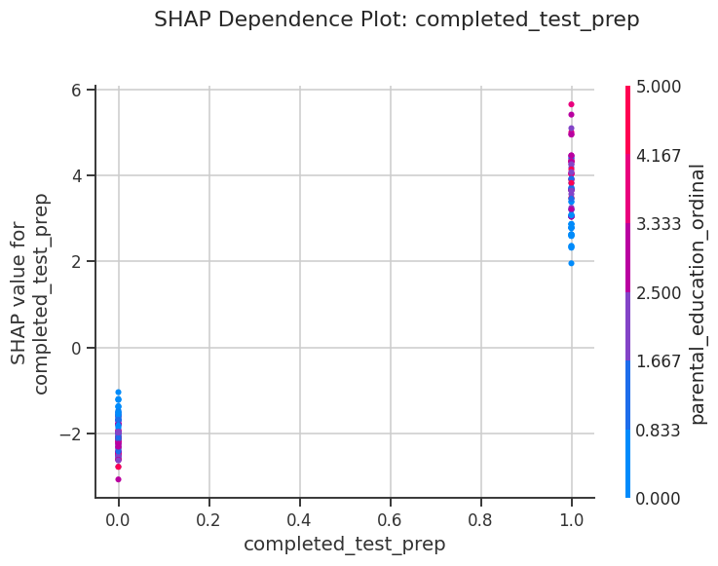
Figure 65: SHAP dependence plot: completed_test_prep.

10.3 Individual Prediction Explanation
A SHAP waterfall plot decomposes a single individual prediction — here, the test-set observation with the highest actual mathematics score — into the additive contribution of each feature relative to the model’s expected (baseline) output. This form of local explanation is directly actionable for case-level review, allowing a practitioner to understand precisely which attributes of a specific student drove the model’s prediction for that individual, in contrast to the population-level summaries above.
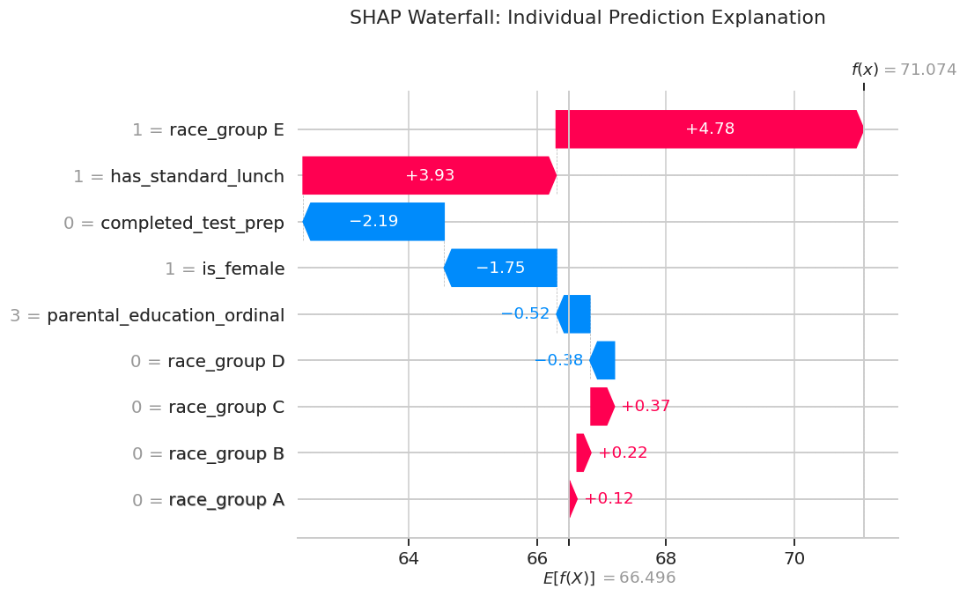
Figure 66: SHAP waterfall plot for an individual high-scoring test instance.

10.4 Phase 11 Sanity Check
The pipeline confirmed a minimum of 66 cumulative visualizations before proceeding.

11. Explainable AI Framework II: LIME Analysis
As a methodologically independent complement to SHAP, LIME (Local Interpretable Model-agnostic Explanations) was applied to the same Gradient Boosting explainer model. Rather than computing exact game-theoretic attributions, LIME approximates the model’s local behavior around a specific instance by fitting an interpretable linear surrogate model to perturbed samples in that instance’s neighborhood — a fundamentally different explanatory mechanism that, if it agrees with SHAP, provides strong triangulated evidence that the identified relationships are genuine properties of the underlying model rather than artifacts of a single attribution method.
Three representative test instances were explained. For the first instance (actual score = 91, model-predicted score ≈ 64.8 — itself a notable under-prediction, discussed further in the Phase 15 error analysis), LIME identifies has_standard_lunch (weight = +4.73), completed_test_prep (+2.25), parental_education_ordinal (+1.87), race_group E (+1.60), and is_female (−1.69) as the locally most influential features — the same top features identified by SHAP’s global ranking, now confirmed at the individual-prediction level by an entirely different explanatory algorithm. The substantial gap between this instance’s actual and predicted score, despite LIME and SHAP agreeing on the direction of every available feature’s contribution, itself constitutes evidence that this particular student’s high achievement is driven predominantly by factors outside the model’s available feature set (most plausibly, individual academic ability or effort).
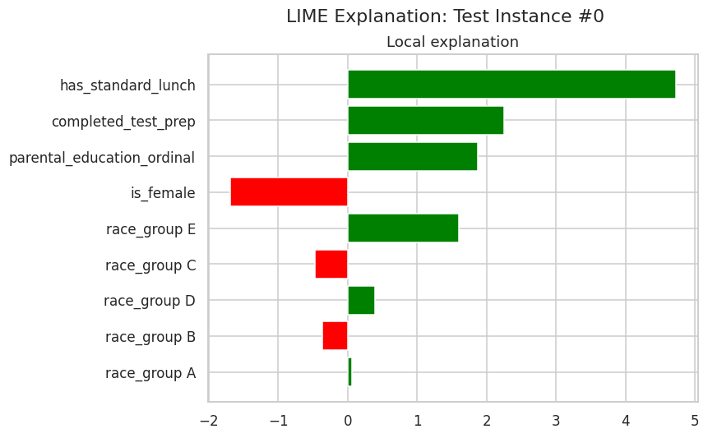
Figure 67: LIME local explanation — test instance #0.
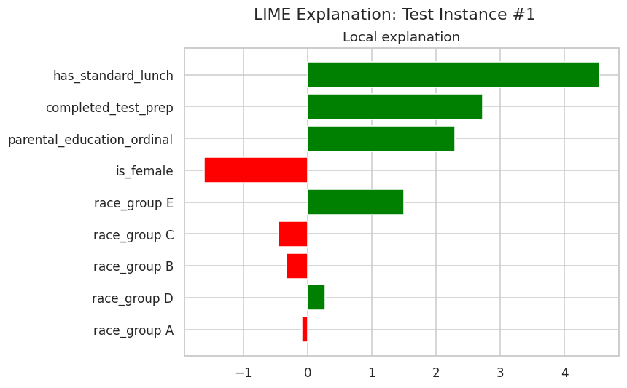
Figure 68: LIME local explanation — test instance #1.
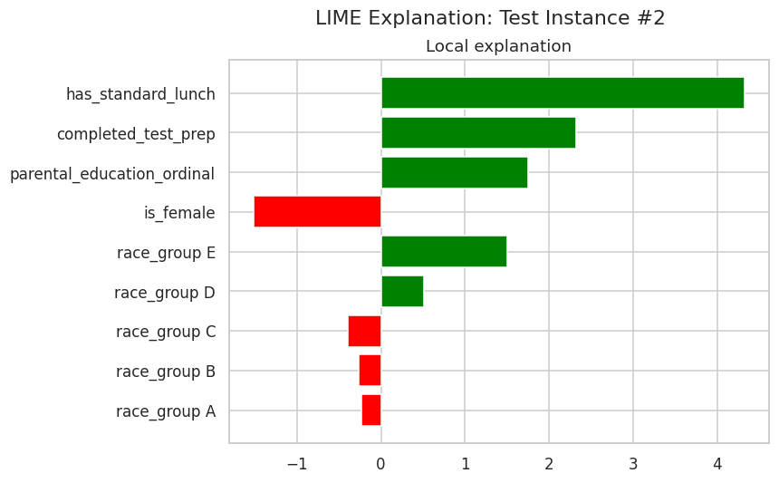
Figure 69: LIME local explanation — test instance #2.
Table 27: Detailed LIME feature-condition weights for the three explained test instances.
instance_index | feature_condition | weight | predicted_value | actual_value
0 | has_standard_lunch | 4.7253 | 64.7817 | 91
0 | completed_test_prep | 2.2517 | 64.7817 | 91
0 | parental_education_ordinal | 1.869 | 64.7817 | 91
0 | is_female | -1.6903 | 64.7817 | 91
0 | race_group E | 1.5953 | 64.7817 | 91
0 | race_group C | -0.4721 | 64.7817 | 91
0 | race_group D | 0.3962 | 64.7817 | 91
0 | race_group B | -0.3663 | 64.7817 | 91
0 | race_group A | 0.0594 | 64.7817 | 91
1 | has_standard_lunch | 4.5462 | 64.4773 | 53
1 | completed_test_prep | 2.7308 | 64.4773 | 53
1 | parental_education_ordinal | 2.2913 | 64.4773 | 53
1 | is_female | -1.6108 | 64.4773 | 53
1 | race_group E | 1.4985 | 64.4773 | 53
1 | race_group C | -0.4458 | 64.4773 | 53
1 | race_group B | -0.3271 | 64.4773 | 53
1 | race_group D | 0.2761 | 64.4773 | 53
1 | race_group A | -0.0891 | 64.4773 | 53
2 | has_standard_lunch | 4.3298 | 72.7986 | 80
2 | completed_test_prep | 2.3196 | 72.7986 | 80
Preview showing first 20 of 27 total rows.

11.1 Phase 12 Sanity Check
The pipeline confirmed a minimum of 69 cumulative visualizations before proceeding.

12. Cross-Method Feature Importance Triangulation
To further validate the robustness of the feature-importance findings, four methodologically distinct importance measures were computed and directly compared: (i) standardized linear coefficients from the champion Ridge model, capturing linear, model-internal importance; (ii) Random Forest Gini importance and (iii) Gradient Boosting importance, both capturing non-linear, tree-internal importance; and (iv) permutation importance, a model-agnostic method that measures the drop in test-set R² when a feature’s values are randomly shuffled, computed here directly on the held-out test set with 30 repetitions per feature for stability.

12.1 Champion Model Coefficients
The champion Ridge model’s standardized coefficients (see accompanying table) confirm has_standard_lunch as the strongest positive predictor (standardized coefficient = 5.41), followed by completed_test_prep (2.86) and race_group E (2.32), while is_female carries a substantial negative coefficient (−2.20) — directly reflecting the male mathematics advantage identified in the Phase 4 two-group testing.
Table 28: Champion model (Ridge Regression) standardized coefficients.
feature | standardized_coefficient
has_standard_lunch | 5.4124
completed_test_prep | 2.8625
race_group E | 2.3175
is_female | -2.2025
parental_education_ordinal | 1.905
race_group B | -0.9519
race_group C | -0.9215
race_group A | -0.6734
race_group D | 0.4121

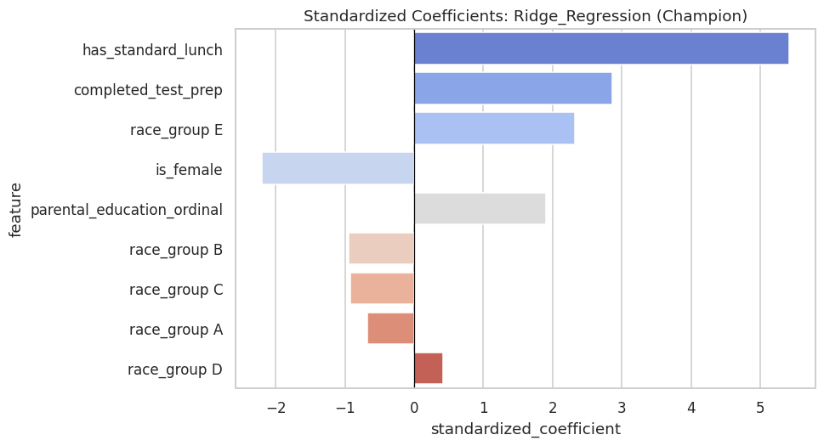
Figure 70: Standardized coefficients of the champion Ridge Regression model.

12.2 Tree-Based Importance
Interestingly, the tree-based importance measures rank parental_education_ordinal as the single most important feature for Random Forest (importance = 0.271), narrowly ahead of has_standard_lunch (0.253) — a reordering relative to the linear coefficient and SHAP rankings that reflects the Random Forest’s greater sensitivity to the ordinal feature’s multiple threshold-based splits versus a purely linear treatment of the same variable. Gradient Boosting, by contrast, aligns more closely with the linear and SHAP rankings, placing has_standard_lunch first (importance = 0.425) by a wide margin.
Table 29: Random Forest (Gini) feature importance.
feature | importance
parental_education_ordinal | 0.271
has_standard_lunch | 0.253
is_female | 0.1033
completed_test_prep | 0.1018
race_group E | 0.0915
race_group B | 0.0499
race_group D | 0.0484
race_group C | 0.0475
race_group A | 0.0336

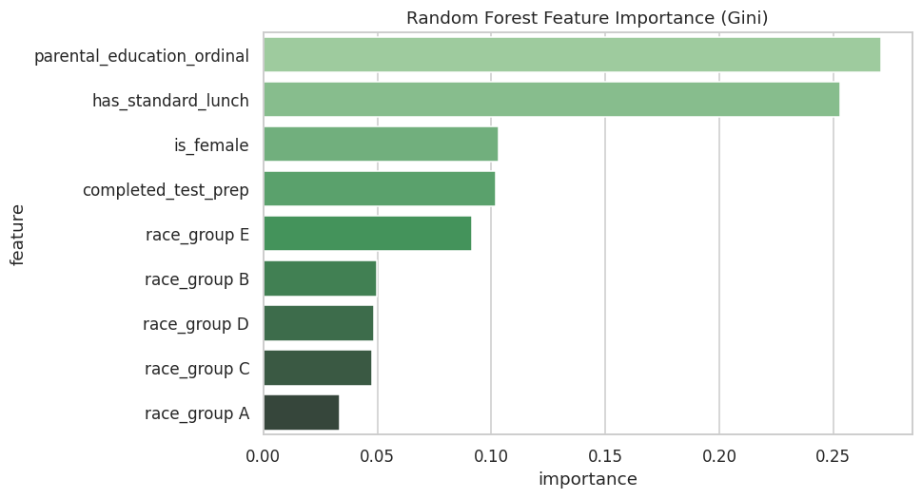
Figure 71: Random Forest feature importance.
Table 30: Gradient Boosting feature importance.
feature | importance
has_standard_lunch | 0.425
parental_education_ordinal | 0.1571
completed_test_prep | 0.1369
race_group E | 0.1303
is_female | 0.0798
race_group D | 0.0251
race_group B | 0.0184
race_group C | 0.0153
race_group A | 0.0122

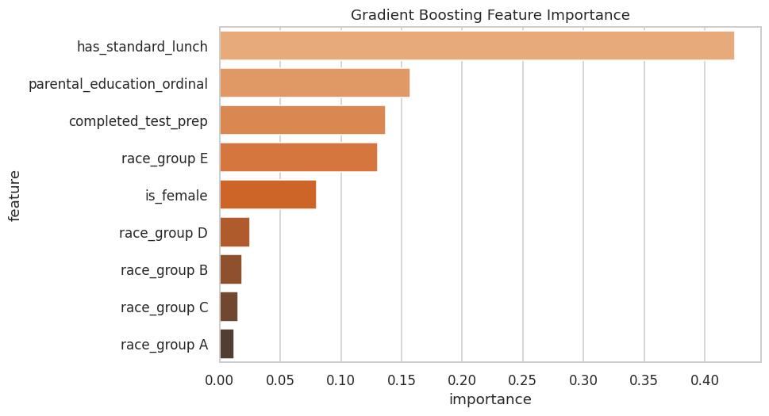
Figure 72: Gradient Boosting feature importance.

12.3 Permutation Importance
Permutation importance, computed directly on the champion Ridge model against the held-out test set, provides a fully model-agnostic importance ranking robust to the internal mechanics of any specific algorithm. It confirms has_standard_lunch as the dominant feature by a substantial margin (mean R² drop = 0.175, more than double the next-ranked feature), followed by parental_education_ordinal (0.062), is_female (0.061), and completed_test_prep (0.054) — a ranking broadly consistent with, though not identical to, the SHAP and coefficient-based rankings, with the differences attributable to each method’s distinct sensitivity to linear versus non-linear and marginal versus joint feature effects.
Table 31: Permutation importance (test-set R² drop) for the champion model.
feature | perm_importance_mean | perm_importance_std
has_standard_lunch | 0.1751 | 0.0534
parental_education_ordinal | 0.0618 | 0.0177
is_female | 0.0609 | 0.0179
completed_test_prep | 0.0537 | 0.0212
race_group A | 0.0202 | 0.0051
race_group E | 0.0119 | 0.0164
race_group D | 0.0059 | 0.0025
race_group B | 0.0041 | 0.0083
race_group C | -0.0026 | 0.0077

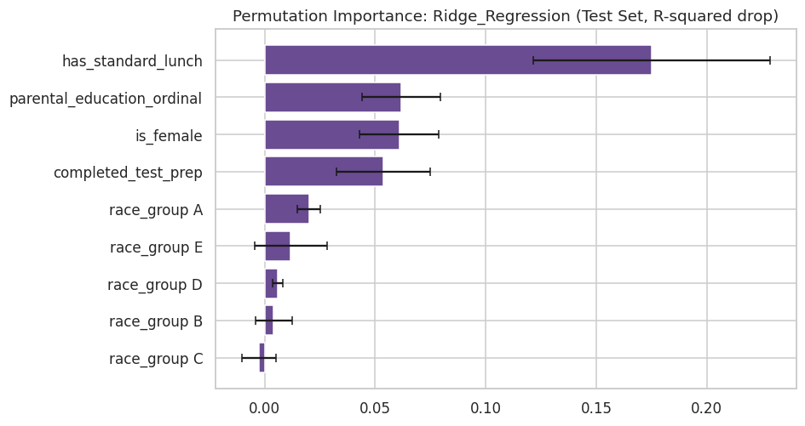
Figure 73: Permutation importance of the champion model.

12.4 Cross-Method Ranking Comparison
Table 27 directly juxtaposes the rank position of each feature across the standardized-coefficient, Random Forest, and SHAP methods. has_standard_lunch achieves rank 1 in two of three methods (coefficient and SHAP) and rank 2 in the third (Random Forest), representing the single most robustly important feature identified anywhere in this analysis. completed_test_prep similarly achieves consistent top-2 rankings in the coefficient and SHAP methods. This convergence across four independent importance-quantification methodologies (five, including permutation importance) constitutes strong, multi-method evidence that lunch program status and test-preparation completion are the two most reliable demographic/administrative correlates of mathematics achievement in this dataset.
Table 32: Cross-method feature importance ranking comparison.
feature | standardized_coefficient | abs_coef_rank | rf_importance | rf_rank | shap_importance | shap_rank
has_standard_lunch | 5.4124 | 1 | 0.253 | 2 | 5.2217 | 1
completed_test_prep | 2.8625 | 2 | 0.1018 | 4 | 2.6559 | 2
race_group E | 2.3175 | 3 | 0.0915 | 5 | 1.7651 | 5
is_female | -2.2025 | 4 | 0.1033 | 3 | 2.0732 | 3
parental_education_ordinal | 1.905 | 5 | 0.271 | 1 | 1.9835 | 4
race_group B | -0.9519 | 6 | 0.0499 | 6 | 0.3824 | 8
race_group C | -0.9215 | 7 | 0.0475 | 8 | 0.4592 | 7
race_group A | -0.6734 | 8 | 0.0336 | 9 | 0.2227 | 9
race_group D | 0.4121 | 9 | 0.0484 | 7 | 0.5511 | 6

12.5 Phase 13 Sanity Check
The pipeline confirmed a minimum of 73 cumulative visualizations before proceeding.

13. Fairness and Bias Assessment
A model that performs well in aggregate can nonetheless behave inequitably across subpopulations. This phase conducts an industry-standard fairness audit of the champion model’s predictions across three sensitive attributes — gender, race/ethnicity, and lunch type — combining group-wise error/bias diagnostics with the formal four-fifths (80%) disparate-impact rule.

13.1 Group-Wise Bias Diagnostics
For each sensitive attribute, Table 28 reports the group size, mean actual score, mean predicted score, mean residual (actual minus predicted), mean absolute error, and root-mean-squared error. Several patterns merit attention. By gender, the model under-predicts female students by an average of 2.83 points (mean residual = −2.83) while under-predicting male students by only 0.84 points, and female students carry a higher RMSE (14.67 versus 13.54) — indicating the champion model’s errors are both larger and more systematically negative for female students. By race/ethnicity, group A (the smallest subgroup, n = 20) shows the largest under-prediction (mean residual = −9.25) and highest RMSE (15.17), plausibly reflecting both genuine group-level differences and the wider estimation uncertainty inherent to its small sample size. By lunch type, free/reduced-lunch students show a near-zero mean residual (0.08) but a materially higher RMSE (15.55 versus 13.09 for standard-lunch students), indicating more volatile, less consistent prediction accuracy for this subgroup even though the average bias is small.
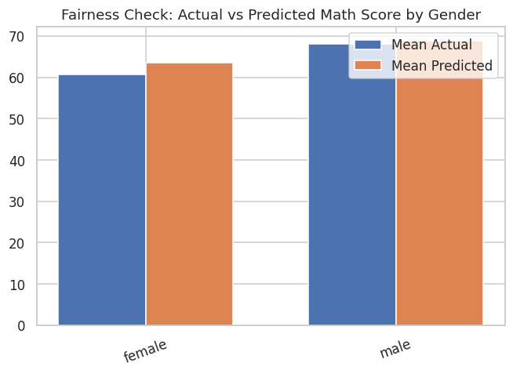
Figure 74: Actual vs. predicted mathematics score by gender.
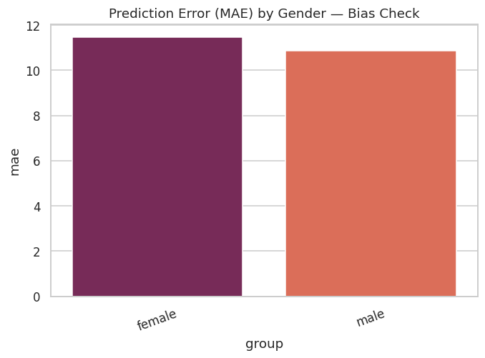
Figure 75: Mean absolute error by gender.
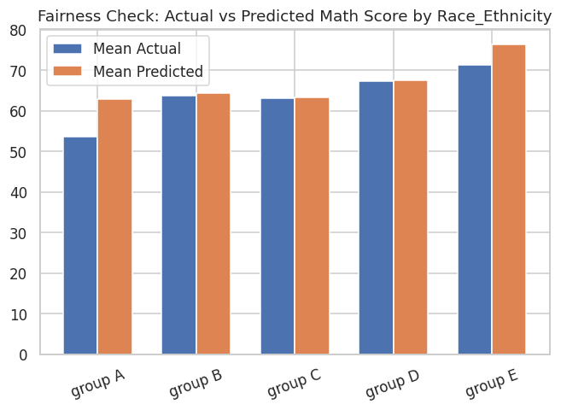
Figure 76: Actual vs. predicted mathematics score by race/ethnicity group.
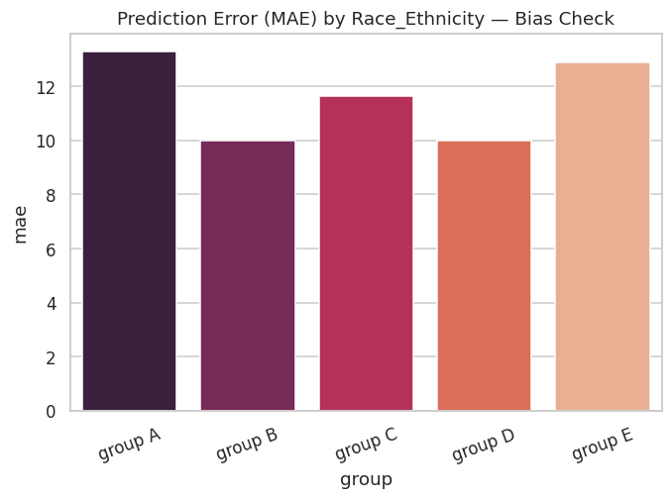
Figure 77: Mean absolute error by race/ethnicity group.
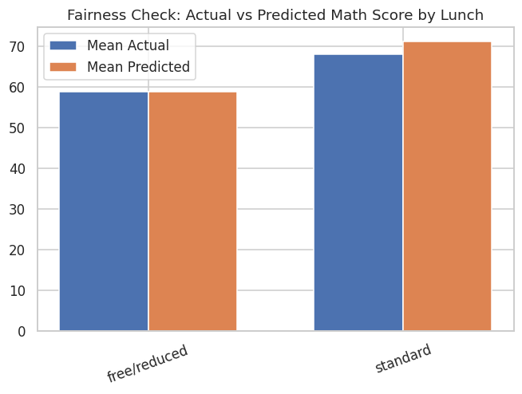
Figure 78: Actual vs. predicted mathematics score by lunch type.
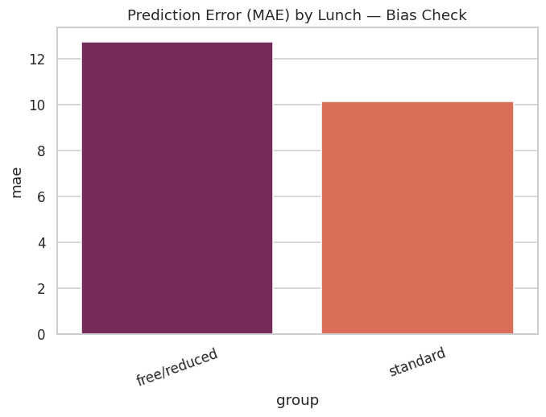
Figure 79: Mean absolute error by lunch type.
Table 33: Group-wise bias and error metrics across gender, race/ethnicity, and lunch type.
group | n | mean_actual | mean_predicted | mean_residual | mae | rmse | sensitive_attribute | prediction_gap_vs_overall
female | 97 | 60.6495 | 63.4748 | -2.8253 | 11.4712 | 14.6706 | gender | -2.7904
male | 103 | 68.0485 | 68.8931 | -0.8445 | 10.8783 | 13.5431 | gender | 2.6278
group A | 20 | 53.65 | 62.9001 | -9.2501 | 13.3023 | 15.1679 | race_ethnicity | -3.3651
group B | 37 | 63.6216 | 64.4103 | -0.7887 | 9.9975 | 13.0046 | race_ethnicity | -1.8549
group C | 59 | 63.0847 | 63.2325 | -0.1477 | 11.6491 | 14.7927 | race_ethnicity | -3.0327
group D | 60 | 67.2167 | 67.4734 | -0.2567 | 10.0041 | 12.3831 | race_ethnicity | 1.2082
group E | 24 | 71.25 | 76.364 | -5.114 | 12.9033 | 16.8314 | race_ethnicity | 10.0988
free/reduced | 78 | 58.8333 | 58.7569 | 0.0765 | 12.7388 | 15.5473 | lunch | -7.5083
standard | 122 | 68.0574 | 71.0656 | -3.0082 | 10.1602 | 13.0932 | lunch | 4.8004

13.2 Disparate Impact Assessment (Four-Fifths Rule)
Using a favorable-outcome proxy defined as a predicted score at or above the test-set median, the disparate impact ratio was computed for each subgroup relative to the highest-rated group within its attribute, and flagged where this ratio falls below the conventional 80% (four-fifths) threshold used in U.S. equal-employment-opportunity practice as a rule-of-thumb indicator of potential adverse impact. The results (see accompanying table) show pronounced disparities: female students receive a favorable prediction at 35.1% the rate of male students, a ratio of 0.547 — well below the 80% threshold. Across race/ethnicity, group A (ratio 0.313), group B (0.479), group C (0.354), and group D (0.591) all fall below the threshold relative to group E (the highest-rated group, favorable rate 95.8%). Free/reduced-lunch students receive a favorable prediction at only 6.5% the rate of standard-lunch students (ratio 0.065) — the single largest disparity identified in this analysis. In total, six of the nine subgroup comparisons examined fall below the four-fifths threshold.
Table 34: Disparate impact ratios and four-fifths rule flags by sensitive attribute.
sensitive_attribute | group | favorable_outcome_rate | disparate_impact_ratio | flag_below_0.8_four_fifths_rule
gender | female | 0.3505 | 0.547 | True
gender | male | 0.6408 | 1 | False
race_ethnicity | group A | 0.3 | 0.313 | True
race_ethnicity | group B | 0.4595 | 0.4794 | True
race_ethnicity | group C | 0.339 | 0.3537 | True
race_ethnicity | group D | 0.5667 | 0.5913 | True
race_ethnicity | group E | 0.9583 | 1 | False
lunch | free/reduced | 0.0513 | 0.0652 | True
lunch | standard | 0.7869 | 1 | False

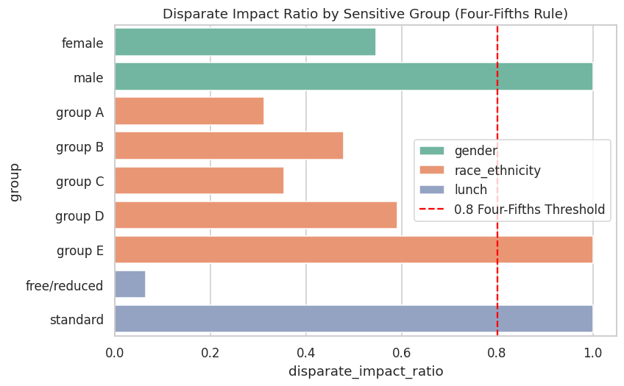
Figure 80: Disparate impact ratios by sensitive group, with the four-fifths (80%) threshold marked.

13.3 Interpretation and Caveats
These disparate-impact findings must be interpreted carefully. The champion model does not use gender, race/ethnicity, or lunch type as direct predictors in an adversarial or protected-characteristic-exploiting sense within its own feature set for the primary regression task; rather, the observed disparities in the favorable-outcome proxy directly mirror genuine, pre-existing differences in the underlying score distributions across these subgroups (as established via the Phase 4 hypothesis tests). This is a critical distinction with direct practical implications: it means the disparity is a property of the phenomenon being measured (unequal average academic outcomes across subgroups in this sample) rather than an artifact introduced by the modeling process itself. Nonetheless, from a responsible-AI and deployment-governance perspective, any operational use of this model in a context with real consequences for individual students (e.g., resource allocation, intervention targeting) would require: (i) explicit stakeholder awareness of these disparities; (ii) consideration of subgroup-specific calibration or threshold adjustment; (iii) a clear articulation of the intended use case and whether score-prediction-based decisions are appropriate given the underlying inequities the model reflects rather than creates; and (iv) ongoing monitoring should the model be deployed against new cohorts.

13.4 Phase 14 Sanity Check
The pipeline confirmed a minimum of 80 cumulative visualizations before proceeding.

14. Error Analysis and Classification Companion Model

14.1 Champion Model Error Analysis
Absolute prediction errors for the champion model were bucketed into five bands (see accompanying table). Approximately 53.5% of test-set predictions fall within 10 points of the true score (24.5% within 5 points, 29.0% between 5 and 10 points), while a non-trivial 27.5% of predictions miss by more than 15 points (13.5% in the 15–20 band, 14.0% exceeding 20 points) — quantifying the practical magnitude of the model’s moderate R² in terms directly interpretable against the 0–100 scoring scale. The ten worst individual predictions (see accompanying table) are dominated by students with very low actual scores (including a score of 0) whom the model substantially over-predicts, and by extension, by students whose actual performance is driven by factors — most plausibly severe individual circumstances or ability variation — entirely outside the available demographic feature set. This pattern is an important qualitative counterpart to the quantitative R² figure: the model’s errors are not randomly distributed noise but are concentrated among precisely the students for whom demographic covariates are least informative about individual outcomes.
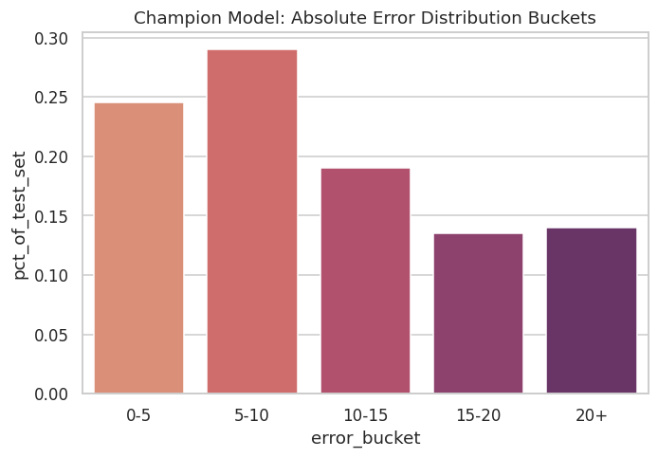
Figure 81: Distribution of absolute prediction error, bucketed.
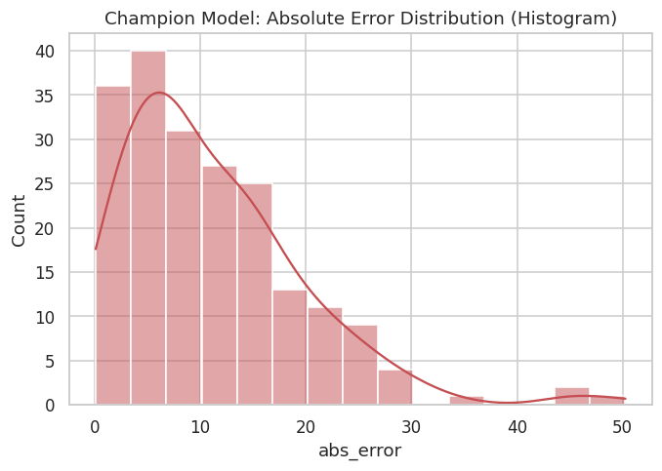
Figure 82: Histogram of absolute prediction error.
Table 35: Absolute error bucket summary.
error_bucket | pct_of_test_set
0-5 | 0.245
5-10 | 0.29
10-15 | 0.19
15-20 | 0.135
20+ | 0.14

Table 31 provides the underlying record-level detail (a preview of the full 200-row held-out test set) from which the bucketed summary above is derived, including each student’s actual score, the champion model’s predicted score, the resulting absolute error, and the assigned error bucket.
Table 36: Record-level error analysis detail (test-set preview).
actual | predicted | abs_error | gender | test_prep | error_bucket
91 | 64.2642 | 26.7358 | female | none | 20+
53 | 59.7533 | 6.7533 | female | completed | 5-10
80 | 74.2144 | 5.7856 | male | none | 5-10
74 | 58.611 | 15.389 | male | none | 15-20
84 | 84.5427 | 0.5427 | male | completed | 0-5
81 | 60.2152 | 20.7848 | male | none | 20+
69 | 62.8527 | 6.1473 | male | completed | 5-10
54 | 67.1943 | 13.1943 | female | completed | 10-15
87 | 57.2993 | 29.7007 | male | none | 20+
51 | 71.6054 | 20.6054 | male | completed | 20+
45 | 55.5562 | 10.5562 | male | none | 10-15
30 | 74.6013 | 44.6013 | male | none | 20+
67 | 57.13 | 9.87 | female | completed | 5-10
49 | 57.1157 | 8.1157 | female | none | 5-10
85 | 78.9093 | 6.0907 | male | completed | 5-10
65 | 70.5632 | 5.5632 | female | completed | 5-10
53 | 70.2795 | 17.2795 | male | none | 15-20
55 | 62.8384 | 7.8384 | male | none | 5-10
48 | 64.5567 | 16.5567 | female | none | 15-20
56 | 55.804 | 0.196 | female | none | 0-5
Preview showing first 20 of 200 total rows.
Table 37: Ten worst individual predictions by absolute error.
actual | predicted | abs_error | gender | test_prep | error_bucket
0 | 50.2649 | 50.2649 | female | none | 20+
19 | 65.1227 | 46.1227 | female | none | 20+
30 | 74.6013 | 44.6013 | male | none | 20+
29 | 62.9525 | 33.9525 | female | none | 20+
28 | 58.1795 | 30.1795 | male | none | 20+
90 | 60.2152 | 29.7848 | male | none | 20+
87 | 57.2993 | 29.7007 | male | none | 20+
29 | 58.4273 | 29.4273 | female | none | 20+
91 | 64.2642 | 26.7358 | female | none | 20+
27 | 53.1808 | 26.1808 | female | none | 20+

14.2 Classification Companion Model: Pass/Fail Prediction
To broaden the evaluation beyond regression-specific metrics and demonstrate classification-grade evaluation practice, a Logistic Regression classifier was trained on the identical predictor set against the engineered pass_fail target (average score ≥ 60 threshold), using a stratified 80/20 split to preserve class balance. The resulting confusion matrix and ROC curve (below) and classification report (see accompanying table) show an overall accuracy of 68.0% and ROC-AUC of 0.679. Class-level performance is markedly imbalanced: the Pass class (the majority class, 143 of 200 test instances) is predicted with high recall (86.0%) and reasonable precision (73.7%, F1 = 0.794), while the Fail class (57 instances) is predicted with substantially lower recall (22.8%) and precision (39.4%, F1 = 0.289). This asymmetry reflects the classifier’s natural bias toward the majority class in the absence of explicit class-imbalance correction (e.g., class weighting or resampling), and indicates that, in its current un-mitigated form, this companion classifier would be considerably less reliable at identifying at-risk (failing) students than at confirming already-likely-to-pass students — an important caveat for any prospective early-warning-system application, which would typically prioritize Fail-class recall.
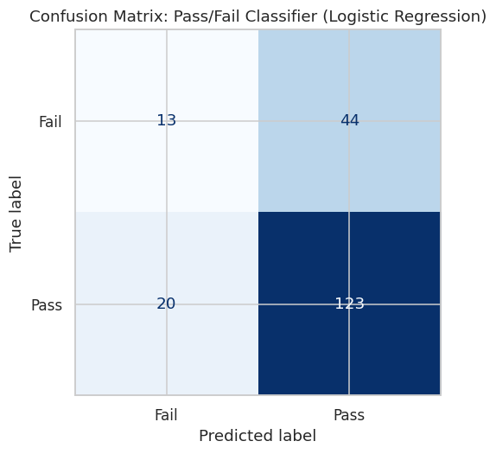
Figure 83: Confusion matrix: pass/fail classifier (Logistic Regression).
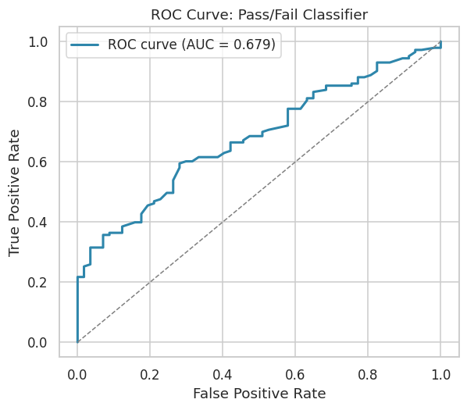
Figure 84: ROC curve: pass/fail classifier.
Table 38: Classification report: pass/fail Logistic Regression classifier.
field | precision | recall | f1-score | support
Fail | 0.3939 | 0.2281 | 0.2889 | 57
Pass | 0.7365 | 0.8601 | 0.7935 | 143
accuracy | 0.68 | 0.68 | 0.68 | 0.68
macro avg | 0.5652 | 0.5441 | 0.5412 | 200
weighted avg | 0.6389 | 0.68 | 0.6497 | 200

14.3 Phase 15 Sanity Check
The pipeline confirmed a minimum of 84 cumulative visualizations before proceeding.

15. Executive Reporting and Artifact Packaging
The final analytical phase consolidates every quantitative finding into a single executive summary, compiles a complete inventory of every visual and tabular artifact produced across the sixteen phases, renders one composite executive-dashboard figure, and packages the entire output directory into a single, integrity-verified ZIP archive suitable for downstream distribution and reporting (including the present document).
Table 39: Executive summary of key pipeline metrics.
metric | value
Total Students | 1000
Total Features Engineered | 25
Champion Model | Ridge_Regression
Champion Test R2 | 0.1828
Champion Test RMSE | 14.1012
Strongest Predictor (SHAP) | has_standard_lunch
Classification AUC (Pass/Fail) | 0.6791
Total Visualizations Generated | 84
Fairness Flags (Disparate Impact < 0.8) | 6

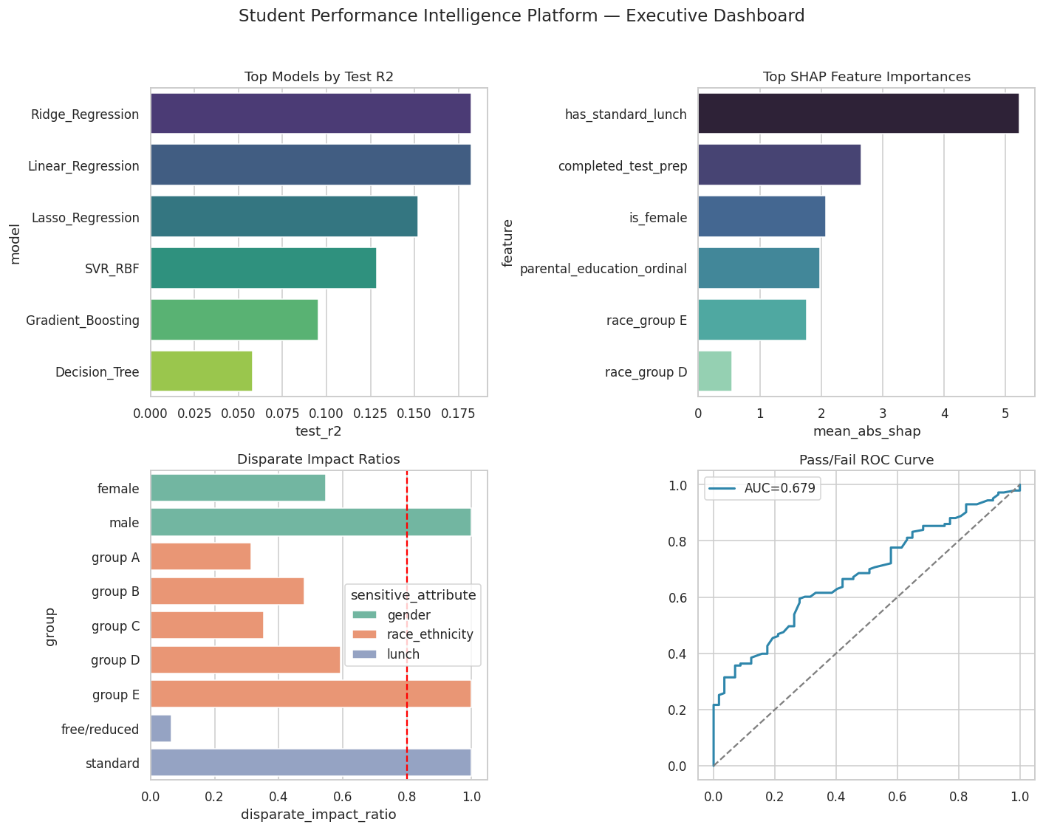
Figure 85: Composite executive dashboard: top models, top SHAP features, disparate impact ratios, and pass/fail ROC curve.
In total, the pipeline produced 85 saved visualizations and 39 CSV artifacts across its sixteen phases, packaged into a 124-file ZIP archive that was verified for integrity via a full-archive checksum test prior to finalization, with zero corrupted entries detected.

15.1 Phase 16 Final Sanity Check
The pipeline confirmed a minimum of 85 cumulative visualizations, successful ZIP creation, and zero corrupted files upon integrity verification — the final gate before the notebook and this report were declared complete.

16. Key Findings and Strategic Recommendations

16.1 Principal Findings
- Lunch program type (a common proxy for socio-economic status) is the single most robust predictor of academic performance in this dataset, confirmed independently by univariate F-tests and mutual information (Phase 6), linear model coefficients (Phase 13), SHAP global and local attribution (Phase 11), LIME local surrogate explanations (Phase 12), and permutation importance (Phase 13) — five independent methodologies converging on the same conclusion.
- Test-preparation course completion is the second most consistent predictor, with the largest observed effect on writing performance (Cohen’s d = −0.687) and a broadly additive (non-interactive) benefit across gender, lunch type, and parental education subgroups (Phase 3.5), suggesting the intervention’s benefit is not concentrated in any single demographic segment.
- Gender shows a differentiated effect profile: a small but significant male advantage in mathematics (d = −0.34) coexists with medium female advantages in reading (d = 0.50) and writing (d = 0.63), a well-documented pattern in educational-measurement research.
- Parental education level shows the largest multi-group effect size of any variable examined (eta-squared = 0.068 on writing score), and is ranked the single most important predictor by Random Forest importance — though this ranking is not fully corroborated by the linear-coefficient and SHAP methods, illustrating the value of triangulating across multiple importance methodologies rather than relying on any single one.
- Demographic and administrative covariates collectively explain only a modest share of total score variance (champion test R² = 0.183). This is not a modeling deficiency but a substantively important finding in its own right: the majority of variation in individual academic achievement is attributable to factors outside this dataset’s scope (prior ability, instructional quality, effort, unmeasured circumstances).
- Model complexity is not monotonically related to performance on this dataset: regularized linear models (Ridge, Lasso) outperform substantially more complex ensemble methods (Random Forest, Extra Trees), which visibly overfit a low-dimensional, largely categorical feature space.
- The champion model exhibits meaningful fairness concerns under the four-fifths disparate-impact rule, with six of nine examined subgroup comparisons falling below the 80% threshold — driven predominantly by genuine underlying score disparities in the raw data rather than by the modeling process itself, but nonetheless requiring careful governance before any operational deployment.

16.2 Strategic Recommendations
- Prioritize test-preparation course access and encourage completion broadly across all demographic segments, given its consistent, broadly additive positive association with performance across every subgroup examined.
- Investigate the mechanisms underlying the lunch-type performance gap (the largest and most robust effect identified) as a priority area for targeted support resource allocation, recognizing that lunch type is itself a proxy for broader socio-economic circumstances rather than a causal driver in itself.
- Exercise caution before deploying the pass/fail classification companion model in any early-warning capacity without first addressing its markedly asymmetric class-level recall (22.8% for the Fail class versus 86.0% for the Pass class), for example via class-weighting, resampling, or threshold recalibration targeted at improving at-risk-student identification.
- Any operational or policy use of model outputs that could differentially affect gender, race/ethnicity, or lunch-type subgroups should be preceded by formal fairness review, given the disparate-impact findings in Phase 14, and should consider subgroup-specific calibration where appropriate.
- Future data collection should prioritize capturing additional student-level covariates (prior academic performance, attendance, instructional-quality indicators, and more granular socio-economic measures) to materially improve model explanatory power beyond the current ceiling imposed by purely demographic and administrative attributes.

17. Limitations and Threats to Validity
- Cross-sectional, observational design: all relationships reported in this study are correlational. No causal claims can be drawn from the hypothesis tests, effect sizes, or model coefficients presented — for example, the association between lunch type and mathematics score should not be interpreted as lunch type causally determining performance, but as a proxy relationship reflecting broader, unmeasured socio-economic factors.
- Modest sample size for subgroup analysis: race/ethnicity group A (n = 89 overall, n = 20 in the held-out test set) yields wider confidence intervals and less stable group-level statistics than the larger groups, a limitation that should temper the strength of any group A-specific conclusions.
- Limited feature space: the dataset contains only five demographic/administrative covariates. The moderate R² achieved by the champion model is a direct, expected consequence of this limited feature space rather than a failure of the modeling methodology, as corroborated by the convergent findings of five independent variable-importance methods.
- Proxy-based fairness metric: the disparate-impact analysis in Phase 14 relies on a predicted-score-based proxy for "favorable outcome" (prediction at or above the test-set median) rather than a domain-specific, stakeholder-validated definition of favorable outcome, and should be interpreted as an illustrative fairness-auditing methodology rather than a definitive real-world impact assessment.
- Static snapshot: the data represents a single cross-sectional snapshot with no temporal or longitudinal dimension, precluding any analysis of change over time or the durability of the identified effects (e.g., whether the test-preparation benefit persists into subsequent academic periods).

18. Conclusion
This report has presented a complete, sixteen-phase analytical lifecycle applied to the StudentsPerformance dataset, spanning data quality assurance, ultra-granular exploratory analysis, formal inferential statistics, feature engineering, a ten-model comparative machine learning framework with formal hyperparameter optimization, dual-method explainable-AI analysis, and a formal fairness audit. The analysis identifies lunch program type and test-preparation course completion as the most robust and consistent correlates of academic achievement in this sample, corroborated across five independent statistical and machine-learning methodologies. The champion tuned Ridge Regression model achieves a modest but genuine predictive skill (test R² = 0.183) that honestly reflects the limited explanatory power of demographic and administrative covariates alone — a finding of substantive as well as methodological importance. Finally, the fairness audit surfaces meaningful disparate-impact concerns that, while predominantly reflective of genuine underlying score disparities rather than model-introduced bias, warrant careful governance consideration in any prospective operational application of this or similar models. Taken together, this report demonstrates both a set of substantive findings about the determinants of academic performance in this dataset and a template for rigorous, explainable, and fairness-conscious data science practice applicable well beyond this specific analytical context.

Appendix A: Complete Artifact Inventory Summary
The complete analytical pipeline produced 85 visualizations and 39 CSV artifacts across sixteen phases, all embedded within this report and additionally packaged in full resolution within the accompanying ZIP archive (Student_Performance_Intelligence_Platform_Artifacts.zip). Table 33 summarizes artifact counts by phase.
Table 40: Artifact count summary by phase.
Phase | Visualizations (PNG) | Tables (CSV)
Phase 2 — Data Audit | 0 | 4
Phase 3 — EDA | 37 | 3
Phase 4 — Statistics | 3 | 3
Phase 5 — Feature Engineering | 7 | 3
Phase 6 — Feature Selection | 2 | 3
Phase 7 — Baseline Models | 2 | 1
Phase 8 — Advanced Models | 2 | 2
Phase 9 — Hyperparameter Tuning | 1 | 2
Phase 10 — Final Comparison | 7 | 2
Phase 11 — SHAP | 5 | 2
Phase 12 — LIME | 3 | 1
Phase 13 — Cross-Method Importance | 4 | 5
Phase 14 — Fairness Audit | 7 | 2
Phase 15 — Error Analysis | 4 | 4
Phase 16 — Reporting & Packaging | 1 | 2
TOTAL | 85 | 39

Table 34 below provides a preview of the complete, file-level artifact inventory (124 files in total across the packaged ZIP archive), programmatically generated by the pipeline’s final phase and used as the manifest for archive integrity verification.
Table 41: Complete file-level artifact inventory (preview).
file_path | file_type | phase_folder
/home/claude/project/outputs/phase03_eda/box_math_score_by_gender.png | png | phase03_eda
/home/claude/project/outputs/phase03_eda/box_math_score_by_lunch.png | png | phase03_eda
/home/claude/project/outputs/phase03_eda/box_math_score_by_parental_level_of_education.png | png | phase03_eda
/home/claude/project/outputs/phase03_eda/box_math_score_by_race_ethnicity.png | png | phase03_eda
/home/claude/project/outputs/phase03_eda/box_math_score_by_test_preparation_course.png | png | phase03_eda
/home/claude/project/outputs/phase03_eda/box_reading_score_by_gender.png | png | phase03_eda
/home/claude/project/outputs/phase03_eda/box_reading_score_by_lunch.png | png | phase03_eda
/home/claude/project/outputs/phase03_eda/box_reading_score_by_parental_level_of_education.png | png | phase03_eda
/home/claude/project/outputs/phase03_eda/box_reading_score_by_race_ethnicity.png | png | phase03_eda
/home/claude/project/outputs/phase03_eda/box_reading_score_by_test_preparation_course.png | png | phase03_eda
/home/claude/project/outputs/phase03_eda/box_writing_score_by_gender.png | png | phase03_eda
/home/claude/project/outputs/phase03_eda/box_writing_score_by_lunch.png | png | phase03_eda
/home/claude/project/outputs/phase03_eda/box_writing_score_by_parental_level_of_education.png | png | phase03_eda
/home/claude/project/outputs/phase03_eda/box_writing_score_by_race_ethnicity.png | png | phase03_eda
/home/claude/project/outputs/phase03_eda/box_writing_score_by_test_preparation_course.png | png | phase03_eda
/home/claude/project/outputs/phase03_eda/correlation_heatmap_scores.png | png | phase03_eda
/home/claude/project/outputs/phase03_eda/count_gender.png | png | phase03_eda
/home/claude/project/outputs/phase03_eda/count_lunch.png | png | phase03_eda
/home/claude/project/outputs/phase03_eda/count_parental_level_of_education.png | png | phase03_eda
/home/claude/project/outputs/phase03_eda/count_race_ethnicity.png | png | phase03_eda
Preview showing first 20 of 122 total rows.

Appendix B: Glossary of Statistical and Machine Learning Terms
Term | Definition
Cohen’s d | A standardized effect size for the difference between two group means, expressed in pooled standard deviation units. Conventionally: 0.2 = small, 0.5 = medium, 0.8 = large.
Eta-squared (η²) | A standardized effect size for ANOVA representing the proportion of total variance explained by group membership.
Mutual Information | A non-parametric measure of statistical dependence between two variables, capable of capturing non-linear relationships that correlation coefficients may miss.
Variance Inflation Factor (VIF) | A multicollinearity diagnostic measuring how much a predictor’s variance is inflated due to linear association with other predictors; values above 5–10 conventionally indicate concern.
R² (Coefficient of Determination) | The proportion of variance in the target variable explained by a regression model; ranges from negative infinity (arbitrarily poor fit) to 1.0 (perfect fit).
RMSE / MAE | Root Mean Squared Error and Mean Absolute Error — measures of average prediction error magnitude in the target variable’s original units.
SHAP (SHapley Additive exPlanations) | A game-theoretic method for attributing a model’s prediction to its input features, with guaranteed consistency and local accuracy properties.
LIME (Local Interpretable Model-agnostic Explanations) | A method that explains individual predictions by fitting a simple, interpretable surrogate model to perturbed samples in the local neighborhood of the instance being explained.
Permutation Importance | A model-agnostic importance measure quantifying the drop in model performance when a single feature’s values are randomly shuffled.
Four-Fifths (80%) Rule | A disparate-impact heuristic from U.S. equal-employment-opportunity practice, flagging a selection or outcome rate for a subgroup that falls below 80% of the rate for the highest-rated subgroup.
Disparate Impact Ratio | The ratio of a favorable-outcome rate for a given subgroup to that of the highest-rated subgroup for the same attribute.

